God’s Greater Story
A Sermon Series on Romans 6-14

Introduction to Series:

Since 2005, National Public Radio has been airing a series called “This I Believe.” Individuals from all walks of life have written and submitted their stories of faith. Essays on what they believe.
These essays are exploratory. Finding blessing in work. Discovering joy in being a neighbor. Trying to have faith in the midst of the messiness of life. The essays are also fragmentary. With over 9 years of testimony and over 70,000 stories archived on the web, “This I Believe” invites you into a world of many beliefs, many personal approaches to the self, to one another, and sometimes to God. One soon discovers that there are as many stories of belief as there are people believing and belief becomes a fragmentary collection of various experiences in the world.
In this sermon series, we add one more story to the collection. This one dates from around 55 – 58 AD and comes from the apostle Paul. Paul was in Corinth, about to journey to Jerusalem to bring an offering from the churches to the poor. As he anticipated that journey, however, he lifted up his eyes and saw something much larger: a missionary trip to Spain. Along the way, he planned to stop by Rome, a place he had never visited. So he sent a letter ahead. To introduce himself as an apostle and to give the Roman church a vision of what he believed. “This I believe,” the apostle Paul said.
As you listen to Paul’s belief, however, you hear a greater story. Paul is not speaking of a belief that is only for himself, a personal theology or a record of his personal spiritual journey. Paul is speaking of God and God’s work among his people, a saving work that includes all nations and that extends throughout all time. Paul’s words of faith are not for himself alone but for all peoples. Paul tells the Romans and us God’s greater story.
Join us now as we enter into the sermon series, “God’s Greater Story.” Listen in as Paul offers his theological vision: a vision of God, Father, Son, and Holy Spirit at work to raise a people for his purpose in the world. Experience God’s claim upon your life as he joins you to a people who have a purpose in his plan to renew creation and reclaim all nations for him.

Overview of the Series

- Baptized into God’s Greater Story

A. Baptized into God’s Greater Story: Romans 6: (1-11) 12-23
Proper 7 (June 22, 2014)

B. The Resurrecting Christ: Romans 7:1-13
Proper 8 (June 29, 2014)

- God’s Greater Story . . .

A. Christ, Our Deliverer: Romans 7:14-25a
Proper 9 (July 6, 2014)

B. God, Our Father: Romans 8:12-17
Proper 10 (July 13, 2014)

C. Holy Spirit, Our Intercessor: Romans 8:18-27
Proper 11 (July 20, 2014)

D. God, in Love, Ruling over Ruins: Romans 8:28-39
Proper 12 (July 27, 2014)

- God’s Greater People . . .

A. People of the Promise: Romans 9:1-5 (6-13)
Proper 13 (August 3, 2014)

B. People with a Purpose: Romans 10:5-17
Proper 14 (August 10, 2014)

C. People who Live by God’s Proclamation: Romans 11:1-2a, 13-14, 28-32
Proper 15 (August 17, 2014)

- God’s Greater Plan for You.

A. Transformed for Service: Romans 11:33-12:8
Proper 16 (August 24, 2014)

B. Living in Love: Romans 12:9-21
Proper 17 (August 31, 2014)

C. Living in Mercy and Faithful Obedience: Romans 13:1-10
Proper 18 (September 7, 2014)

D. Living in Light of Christ’s Eternal Rule: Romans 14:1-12
Proper 19 (September 14, 2014)
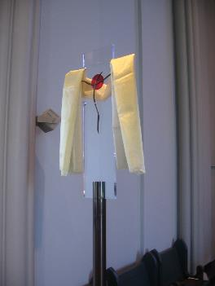
Date: Proper 7 (June 22, 2014)
Text: Romans 6: (1-11) 12-23
Title: Baptized into God’s Greater Story

Focus: In baptism, God brings us into his
greater story.
Function: that the hearers confess that they
are dead to sin and alive to God
in Christ Jesus.

Structure: Frame and Refrain Structure

Sermon Study

Opening Frame:

Have you ever caught your reflection in a window?
It can happen in a moment. Your husband has taken the kids outside to play and to give you two hours of quiet so that you can pay the bills and sort through that pile of papers on the table in the corner. After about an hour, you stop working to get something to drink. You go to the kitchen and look out the window. Your kids are running around in a circle. Your husband is in the middle trying to catch them. As you turn to go back to the table, the light suddenly changes and . . . for a moment . . . you see your reflection in the glass. There you are, in the middle of the circle . . . with your husband. Your children are running around, laughing, and you are caught up in their joy. Seeing your reflection in the glass, even if only for a moment, changes the way you return to your work. The drudgery of bills and the details of budgeting are just one small part of a much larger story. A story where God has taken you, surrounded your with a family, and brought you into the joy of life.
I’d like to focus on a moment like that this morning. A moment when you catch your reflection in the glass. We come here this morning from many different places. Some are struggling with loneliness, others with depression. Some have just started a job, while others are anticipating going away to college. Regardless of where you are in life, where you have been or where you think you are going, God has brought you to this place. Today, he asks you to stand here and look through a window. To glance for a second at the ministry of the apostle Paul.

During the weeks to come, we will be reading from Paul’s letter to the Romans. It’s a missionary letter, written to a church that Paul had never visited. Yet, in his words, Paul offers a vision of God at work in the world. Paul may not know these people but he does know their God and the way their God works in the world. Knowing that, Paul gives them a glimpse of the greater story of God. He trusts that when they hear that greater story, they will catch their reflection in the glass. They will see how God has brought them into something greater than living in Rome in the first century AD.
God’s word is like that. It changes how you live. It reveals to you something bigger than yourself and makes you part of something larger than your life. It worked like that then and it works like that now.
Centuries have passed since Paul first wrote this letter. Rome has fallen. Empires have come and gone. The way we relate to one another and the world around us has changed. Yet the work of God continues. God is still at work through his word and Spirit. And so, we come to meditate on God’s words to the Roman Christians. To stand at the window and look across the centuries. Starting at Romans 6, we will read to the end of the letter. Week after week, we will see the story of God unfold. Today, we begin with God’s work in baptism. The way God joins us to the power of the resurrecting Christ. Then, we will focus on God’s greater story, God’s greater people, and God’s greater plan for you.
Come. Listen. Watch, as God makes you part of his larger story. Catch your reflection in the glass. It will change the way you live in God’s world.

I. In baptism, God brings us into the middle of an on-going story

Today, we begin in the middle of the book of Romans. Romans 6. How strange to start reading in the middle of a letter. It catches you off guard. It would be much easier to start at the beginning. To hear Paul, introducing himself to the Romans, and then to follow the flow of the letter. But we are going to start with Romans 6. Why?
Because sometimes that’s the way God works in the world. We are brought into the middle of an on-going conversation. We overhear people talking and, over time, we discover who they are. Our family in Christ. When you were born as an infant, you entered a world already set in motion. You didn’t know who people were as they passed you from person to person at the hospital. Over time, however, you recognized voices and put together stories. Strangers became family and a simple gesture could remind you of love.
In a similar way, God’s work does not start with you. No, you have been brought into God’s family. You were not there in the very beginning. God alone existed. He existed before anything else was made. And God alone created this world out of nothing. He spoke and the flowering dogwood appeared. Mountains soared. Waves crashed. After preparing a world for his creatures to discover, after preparing a garden for his creatures to live in, after preparing food for them to eat, day and night for them to rise and sleep, God took the dust of the earth, formed it, fashioned it, and breathed into it the breath of life. God made Adam and Eve and brought them into his story.
What God did at the first creation, he continues to do in a new way for each generation. Although Adam and Eve sinned and brought death, the punishment of sin, into the world, God continued to work. He sent his Son, Jesus, to bear the punishment of death, and to prepare a place for his people. A new creation. A place free from death. A place where God’s people will rejoice in the goodness of God and the wonder of a new creation. In baptism, God brings people into his story. God gathers people from all ages and places, from all languages and cultures, into his kingdom. The infant in arms and the aged on her deathbed. Those who speak Mandarin and those who speak Yoruba. Those who gather water from wells and those who keep bottles of purified water in their fridge. God brings all people into his story through the waters of baptism. In baptism we are joined to the death and resurrection of Christ and there we enter the story in the middle. This story reaches back before creation, when God loved us before the foundations of this world, and this story reaches forward to a new creation when Christ will return and restore all things.
God’s story doesn’t begin with you and it doesn’t end with you. But it does include you. By grace, you have a place and a purpose and you are part of a people. And to understand that, to understand how God brings you into his much larger story, it is helpful to start in the middle of Paul’s letter. Because here Paul brings you to the waters of baptism and there you see what it means to be buried into the death and resurrection of Christ.

II. In baptism, we are dead to sin and alive to God (vv. 10-11):

Paul describes this moment most clearly when he writes, “The death he died, he died to sin once for all; but the life he lives, he lives to God. So, you also must consider yourselves dead to sin and alive to God in Christ Jesus.”
Dead to sin and alive to God in Christ Jesus. That is what you are. This is a hard truth for us to hold onto. God’s work is eternal. This promise of God is certain and lasts for all time. But sometimes it is hard for us to hold on to this truth of who we are. It is as if this is only a moment for us, especially as Lutherans.
For example, ask any Lutheran about their Christian life experience and I would dare say that these are not the first words off their lips. Romans 6 is not our favorite text. Ask Lutherans about their life experience and they will quote Paul, but they quote Paul from Romans 7: “The good that I would do, I do not and the evil that I would not do, that I do.” This life of struggle, this internal division, this fighting of the flesh and the Spirit, this is a typical way for Lutherans to speak about Christian life. Yet, Paul this morning asks us, for a moment, to say something else about ourselves. Paul says, “Consider yourselves dead to sin and alive to God in Christ Jesus.” Sometimes you wonder if Lutherans have all received bibles where the pages in Romans were stuck together so that they go directly from Romans 3 to Romans 7. Paul asks us this morning to peel apart those pages and to take a deep long look into the reflective pool of baptism. There we see our reflection in the waters and learn to say, “I am dead to sin and alive to God in Christ Jesus.”

Let’s mediate for a moment on those words. Paul has described sin with power and force in the letter to the Romans. It is a sin which enslaves, a sin which imprisons, a sin which has dominion. That sin, Paul says, consider yourselves dead to it. Paul has described God in wonder and power in Romans. This is the God who created all things, the God who rose from the dead, the God who now reigns in the glory and wonder of heaven. The God who sends his Spirit among his people, the God who frees, the God who lives, the God who brings about a marvelous new creation. That God, Paul says, consider yourselves alive to that God in Christ Jesus. Dead to sin and alive to God in Christ Jesus. For Paul this is the meaning of our baptism. As Paul says, “we were buried with him in baptism to his death so that, just as Christ was raised from the dead by the glory of the Father, we too might walk in newness of life.” Therefore, consider yourselves dead to sin and alive to God in Christ Jesus.

III. Because of baptism, we present ourselves to God as instruments for righteousness (v. 13):

I hope you can see how different Paul’s ways are from the ways of the world. Our world recognizes the power of sin. But it fights sin by asking us to remember it. In that is our hope. If we can remember our sin, we will avoid it in the future.
You go to the museum of tolerance in Los Angeles and you will find yourself taken along a circuitous route of displays. You will see the homes and streets of Nazi Germany. Your time in each space will be carefully controlled. Doors will open and lights in the next exhibit will brighten, beckoning you forward; and lights in the present exhibit will dim and doors will close shutting you in. As you make your journey, the space around you will become smaller, the rooms darker and finally you will be forced to enter one of two tunnels according to whether you are male or female. You will find yourself in a room the shape of a gas chamber. A huge concrete slab fills the center, with no place to be comfortable. The lights darken and the TV monitors brighten and you are surrounded with newsreel footage of infants thrown out of hospitals and human beings treated worse than cattle. This chamber then opens onto the present world and an exhibit on tolerance. Your memory of sin is your hope for the world.
Paul offers another way. As you read through Romans, you find that Paul takes you down this darkening hallway and sets before you the severity of human sin. You see the power of sin in the world. The power of sin in your own life. It affects all so that none are free from its dominion and all stand sinful before God. But Paul does not stop there. Paul goes deeper than that. The chamber he takes you into is one where the monitors darken and the newsreel footage stops. In the absence of light, you feel a slab of stone and hear the sound of dripping water. Paul takes you to the moment of baptism when you were buried with Christ.

Deeper than our sin and darker than our suffering lies the suffering of God. The death of Christ for the sin of the world. Those who see here see only by the light of God. This death is the punishment of sin. And this resurrection is life and light for the world. “Arise, shine, for your light has come and the glory of the Lord has risen upon you.” God has entered your world, taken your sin upon himself, and in his resurrection raised you to life. Just as Christ was raised from the dead by the glory of the Father, you too walk in newness of life. Paul brings us from the newsreel footage of our sin that plays over and over in our minds to the wonderful reality of the death and resurrection of our Savior who takes us by the hand and leads us into a new life. We are brought into his kingdom and we live as servants of God.
For this reason, Paul calls upon the Romans then and us today to present ourselves to Christ Jesus as people who have been brought from death to life. We present our bodies, our minds, our skills, our talents, as instruments for righteousness. There is a beautiful mystery to being part of God’s story. We often find ourselves amazed at what God will do. We bring our lives to God, present ourselves to him, and God uses our lives in the unfolding of his kingdom.
A woman, dying of cancer, discovered this. Marie’s time was short. Her bone cancer had metastasized and progressed to other parts of her body. She had just entered into hospice care. A confirmation student, Amy, came to visit her. She had been her prayer partner. Her parents didn’t think Amy should have done this. “Hospice is no place for a child,” her mother said. But Amy wanted to go and Marie was happy to see her. It was awkward. Amy didn’t know what to say. She was just so conscious of the fact that Marie was dying. It made everything she thought about saying seem stupid. So, she sat there. And held her hand. Marie, however, started talking. She told Amy what it meant to see young adults in church. Why she wanted to pray for the confirmation students. She could only imagine the challenges they faced. That led to a conversation about faith. How important it was. She spoke of her hope. Even now. Her hope for that day when Jesus would return and she would have a new body, without sickness, without pain. How comforting to know Jesus, raised from the dead, returning to bring her into his new creation. In a sense, Amy’s mother was right. “Hospice is no place for a child.“ But God knows that and so God sent his Spirit to guide the conversation. God used Marie to fill that room with hope. A hope that lives even in the face of death. Marie’s life became an instrument for righteousness. A revelation to Amy of hope that lives in the face of death. In a room filled with dying God used Marie to speak about a world filled with life.
As Christians, we confess that we are dead to sin and alive to Christ. And we present our bodies to God as instruments for righteousness. There is no telling what God will do through you as he works in the world.

IV. Closing Frame:

In St. Louis, in the seminary chapel, stands a processional cross. It looks like a transparent piece of glass. You could see right through it if it weren’t for the small figure of Christ hanging in a spot of blood. His body offered for the world. Usually, this cross stands behind the pulpit. A visible reminder of what is being preached from God’s word. Sometimes, however, the cross is used in procession. When God’s people celebrate epiphany, the baptism of Jesus, his transfiguration, his resurrection, his ascension. Or, when God’s people celebrate moments of Christ’s work in the seminary: the opening of the school year, commencement, the day candidates receive their first call. On those days, they take this cross from its place and carry it back to the baptismal font. There, joined to those waters, it begins a procession, into worship and out to the world. It doesn’t happen often but when it does, something wonderful occurs.
When that cross is used in procession, it changes. Normally, as it stands behind the pulpit, you see right through it. It’s transparent. Jesus hidden and revealed, one could say. But when it enters into procession the surface no longer is transparent. It becomes reflective. As the crucifer carries it through the congregation, the cross catches the world around it. Draws images from the world into itself. The cross is filled with people. People who are gathered in worship. Their faces uplifted, their mouths open in song, their hearts filled with anticipation at what is about to be done. This body of believers is all caught up there, visibly joined to the passion of Christ. If you look closely, you can see your reflection in the glass. Your life joined to Jesus. A moment that reminds you of what God does in this place.
In baptism, he has joined you to the death and resurrection of his Son. Your life is part of God’s greater story. As you now stand before God about to enter the world, for a moment, you have the courage, you have the joy, you have the privilege to say, “I am dead to sin and alive to God in Christ Jesus.” And you present yourself to God as an instrument for righteousness. Amen.

Date: Proper 8 (June 29, 2014)
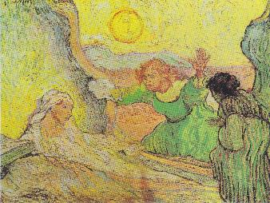
Text: Romans 7:1-13
Title: The Resurrecting Christ

Focus: Christ raises us to life in him.
Function: that the hearers may find
freedom and formation in
the risen Christ.

Structure: Frame and Refrain Structure

Sermon Study

Opening Frame:

For a year, Vincent Van Gogh had been in a mental asylum in the southern part of France (Saint-Rémy-de-Provence). At times, he was allowed outdoors on the grounds, accompanied by an attendant. At other times, he was confined to the building, painting scenes he saw through the window in his room. Van Gogh was disturbed. Not only by the confines of his room but also by the confines of his mind. He suffered seizures and mental distress. Where could Van Gogh go for relief?
Into his suffering and confinement came a letter. Small but powerful. It came from his brother, Theo. Theo sent Van Gogh a copy of an etching by Rembrandt. In that letter and in that etching, Van Gogh discovered life and hope.
The picture that Theo sent was Rembrandt’s fifth etching of “The Raising of Lazarus.” In it, Jesus stands there. A ruling figure. Towering. Powerful. Looking out over the scene. At his feet, Lazarus is coming out of the tomb. No one looks at Jesus. All eyes are on Lazarus, as he rises from the grave. Yet Jesus stands there, the Resurrection and the Life. Here is the Resurrecting Christ. From him comes all power. The power over death and the power of life. In his rule, he raises Lazarus, opening the eyes of all people to see power. The power of the resurrecting Christ.
When Van Gogh received this picture, he was inspired by its power. He remembered the etching. He remembered what had been written about it. But, when he looked at it, he saw more than could ever be written. He pondered it, painted it, and sent his brother a letter, with his own small etching, trying to put into words what he saw.
Here, in the suffering and confinement of an asylum, Van Gogh experienced the power of the Resurrecting Christ. Written in letters, painted on canvas, the Resurrecting Christ brought life and hope and beauty into the world.

I. The Power of the Resurrecting Christ:

Our text this morning is another letter. A letter that proclaims the power of the Resurrecting Christ. The apostle Paul first sent this letter to the church in Rome but it comes among us today to bring life and hope and beauty to our world.
The power of Christ is found not only in this text but actually flows throughout Paul’s letter. Consider how he opens the letter: “Paul, a servant of Christ Jesus . . . [who] was declared to be the Son of God in power according to the Spirit of holiness by his resurrection from the dead” (1:1 and 4). Here, Paul presents himself in language very similar to that used by servants of Caesar, only the powerful ruler that Paul serves is not Caesar. Paul serves Jesus Christ, the ruler of all things, declared to be the Son of God in power by his resurrection from the dead. Paul then states the main theme of his letter: “For I am not ashamed of the gospel, for it is the power of God for salvation to everyone who believes” (1:16). Paul’s letter is all about power. The power of the gospel to bring salvation to the ends of the earth. Finally, consider how Paul closes the letter, “The God of peace will soon crush Satan under your feet. The grace of our Lord Jesus Christ be with you” (16:20, cf. also 15:18-19). God’s power is there at the beginning of Paul’s letter, at the end of Paul’s letter, and all the way through. Paul’s letter is filled with the power of the resurrecting Christ, bringing life and salvation to all people.
And why wouldn’t it be? Paul, himself, had met the resurrected Christ and, in that meeting on the Damascus road, Paul discovered Jesus to be more than the resurrected Christ. He was also the resurrecting Christ. When Jesus appeared after his resurrection, he changed lives – Mary outside the tomb mourning, Thomas in the room doubting, Peter out on the lake fishing. Individuals raised from sorrow and fear and discouragement to life. And last but not least, the apostle Paul. Christ appeared to Paul on the road to Damascus and raised him to life. Paul now proclaims this power to all people, to the church at Rome and to us today. Paul turns our eyes to Jesus, for Jesus raises us to life.

II. Frees Us from the Condemning Power of the Law:

Sometimes, however, Jesus is hard to see. Like the figures in Rembrandt’s etching, people are looking everywhere except to Christ.
For the church in Rome, Paul was concerned that people were looking to the law as a source of life. Israel believed in God’s law. God’s Torah was good. It was a design for life and they couldn’t imagine their relationship with God apart from it. They saw the law as a power for life. They turned to that law, seeking to obey it, in order to participate in God’s life in the world. Unfortunately, they were so focused upon the law that they lost sight of Christ.
Example: consider a family that brings their son to Sunday school not because they want him to grow in relationship with Jesus but simply because they want him to learn the Ten Commandments and get a good moral foundation. Later, he may choose to follow God in any religion; for now, what is important is that he get the basics. The law of God. This family sees the law as holy and righteous and good. But they have lost sight of God.
Paul writes this letter to be sure that no one sees the law without seeing Jesus. And Paul does this because he knows something. Paul knows the terrifying power of the law. It has power, all right. The power to awaken our sin. Although the Romans may see life in the law, Paul knows that eventually they will see death. God’s law is good but our lives are not. Holding on to the law without Christ is like holding on to a knife as it cuts you to death. The law has a condemning power. Paul writes that it arouses “our sinful passions.” When you hear what you are not supposed to do, you end up wanting to do it. Paul didn’t know what coveting was until he was told not to covet and then sin awakened and created all kinds of coveting within him. Sin comes alive and we end up dying. Dying while holding on to the good law of God.
For this reason, Paul points us to Christ. The One who dies while holding on to us. We were sinners in the hands of an angry God but now we are sinners in the hands of our gracious Savior. Christ saw us in our sin and offered his life for our salvation. He died under the condemning power of the law for you. Through his dead body Jesus Christ sets you free.
As Paul writes, “Likewise, my brothers, you also have died to the law through the body of Christ.” In his death, Christ puts to death the condemning power of the law. By his death, Christ brings life to you. Those who see the law and hold on to it without Christ will ultimately die. You, however, who are baptized in Christ, are baptized into his death and, by his death, Christ sets you free.

II. Forms Us to Live as a People for God:

Paul reveals the power of Christ to set us free from the condemning power of the law and to raise us to life as a people for God.
It seems odd, to be living in America, and listening to Paul tell us about freedom. After all, as Americans, we pride ourselves on freedom. Freedom of speech, freedom of the press, academic freedom . . . the list goes on and on. In fact, in America, our infatuation with freedom has led some to believe that they have the freedom to rewrite the laws of God and create a different way of living in the world.
In Deuteronomy, God commanded Israel to remember his commandments, to “tie them as symbols on your hands and bind them on your foreheads” (Deut. 6:8). And that’s precisely what they did. God’s people literally tied his word to their bodies, winding leather straps up their arms. For many, that’s how the law of God feels today. Christianity is binding. It’s filled with rules and regulations. It constrains you and drains you of the joy of life. You can’t do what you want when Jesus calls you to love your neighbor. You can’t follow others when Jesus calls you to follow him.
So, some Christians celebrate a freedom from God’s good design. A distinctly American freedom from the laws of God. Take God’s good design of marriage or human sexuality. Such things can be redefined. To fit our present day. It is our manifest destiny to redefine the ways of God for our 21st century world. These redefinitions of God’s law stress that God is loving and good. His love and his goodness set us free us to be whatever we want to be. Old notions of sin and punishment and the law of God are discarded as we live in the freedom of the American dream and claim that God is loving toward us and good.
Such attitudes, however, would seem strange to the apostle Paul. The law of God is not something you can redefine. The law is God’s. It is part of God’s design and it has been built into creation. You can delude yourself that it doesn’t exist or that it doesn’t matter to God. But in the end, you will be held accountable to God. A person could pretend that laws don’t exist in our community. She could go into a store and simply walk away with merchandise taken from the shelf. She could go into a home that she likes and try to start living there. In the end, however, she would discover that she is not alone, she does not make her own laws, but she is part of a larger community and lives under its laws.
So, too, Paul wants you to know that you are not alone. God does exist and rules over all creation. He has set his law in place and everyone will be held accountable to it before him. He has claimed you in the death of Christ, to free you from the condemning power of the law; but he has also raised you in the life of Christ to live and bear fruit for him.
Christ stands there, on the edge of Paul’s letter, ruling over the world and raising people to life in him. Paul does not stop after writing about the death of Christ. He continues. He writes about the resurrection of Christ because he knows that we have been raised to new life in him. Paul writes, “Likewise my brothers, you have also died to the law through the body of Christ, so that you may belong to another, to him who has been raised from the dead in order that we may bear fruit for God” (7:4). With these words, Paul turns our attention to the resurrecting Christ. He not only frees us from the condemning power of the law but he forms us by his Spirit to live as a people for God. In him, our lives are shaped by the Spirit and reveal the goodness of God’s law, God’s ways, God’s people in the world.

Closing Frame:

When Van Gogh looked at the etching by Rembrandt, he couldn’t put what he saw into words. He tried but he couldn’t find the words.
Instead, Van Gogh painted his own Raising of Lazarus, based on a small detail in this etching. Van Gogh focused in on the figure of Lazarus rising from the grave. Martha is pulling the veil from his eyes and Lazarus is only beginning to see the world again. Jesus is not even in the painting. He stands as that ruling figure in the background, not seen by Lazarus, not seen by his sisters, not seen by the viewer, but known to be there. What is seen, however, is amazing.
If you look closely at the face of Lazarus, rising from the grave, you see that Van Gogh painted himself into Lazarus. There he is, a thin pale man with a red beard, rising from the grave. Not yet able to see all that God has done for him, not yet able to see Jesus ruling over all, only beginning to live, to taste the wonder of the Resurrecting Christ in his flesh in this world.

In the same way, Paul’s letter invites us to live in the power of the Resurrecting Christ. Though we do not see him now, we know that he is risen and ruling over all things. His law is holy. His commandments are holy and righteous and good. In him, we have died to the curse of the law, in his body crucified for us on the tree. In him, we have been raised to a new life in the Spirit. And we are only now beginning to experience the first fruits of faith in the kingdom of God. Amen.

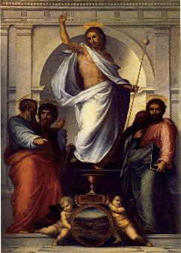
Date: Proper 9 (July 6, 2014)
Text: Romans 7:14-25a
Title: Christ, Our Deliverer

Focus: Christ is our deliverer, rescuing us in our
struggle with sin.
Function: that the hearers may receive the Lord’s
Supper in faithful confession of their sin
and trust in the power and mercy of God.

Structure: Multiple Image Design

Sermon Study

Introduction:

Sometimes the smallest thing can tell a greater story. Your great grandmother’s hope chest. Stone markers telling of Civil War battles. The smallest things can tell much greater stories, extending over time, involving many people.
Consider a well-used silver cup, about the size of a chalice. It was buried in the homestead of a once prosperous Roman family. When Mount Vesuvius erupted in 79 AD, it was valuable enough to be buried in a wine cellar but not valuable enough to be taken along as the family fled for safety. This one small cup belonging to one unnamed family told of a much larger story. A story of gods and humans. The story of Rome and what it was like to live under the rule of Caesar Augustus.
On one side of the cup is the image of Augustus, surrounded by gods. He is seated, and being handed the world by Venus and winged Victory, while Mars, the god of war, brings before him a multitude of conquered nations. On the other side of the cup is the image of Augustus, ruling over people. Here, the image is one of mercy and not of war. Augustus is seated, people are coming before him, and he extends one hand out to the people while in the other hand he holds a spear.
This image of the emperor was common throughout Rome at the time when Paul wrote his letter. It was carved into marble friezes, printed on coins, molded into ceremonial cups like the one found in the Italian villa. It helped people understand what it meant to be faithful. Faithfulness was the word used to describe the relationship between the conqueror and the conquered. The emperor held both power and mercy. In power, he would protect his people – so you see him with a spear in his hand – in mercy, he would rule his people – and so you see him reaching out with an open hand. Power and mercy in this one figure, ruling over people, one small actor in the much larger story of the gods.

When Paul wrote Romans, he offered another story of another conqueror who ruled over people in power and mercy. This God and man was Jesus the Christ.

I. The Conquered:

The small portion of the letter that we have before us today is well-known among Lutherans. It names a struggle, the struggle between sinner and saint. This struggle is real and hidden in the heart of every person. Some people confess this struggle openly, asking others to help them in relationships of accountability; other people hide this struggle, putting on the best face they can. All people, however, suffer this struggle and it is not something, like that cup, that can be left behind. Until the day when our conqueror, Jesus Christ, returns, we will be involved in this struggle of being a sinner and a saint.
Paul’s description is personal, individual. It tells the story of one man and one struggle that never seems to end. Paul knows the good that God desires and Paul himself agrees with this desire. He acknowledges that what God wants is indeed good. Yet Paul also discovers that he is “sold under sin” (7:14). Paul uses the language of slavery and of captivity. His members “wage war” and he is “captive” to the law of sin (7:23). Paul knows the good that he wants to do, but he is unable to do it. Instead, he finds that what he doesn’t want to do, that he does. A slave to sin, a captive to his flesh, Paul cries out for deliverance.
His story, however, is not the story of only one man. This is the story that touches all people. Paul’s cry is that of Cain, knowing the good that God wants him to do and yet also knowing the evil that is close at hand. Joseph’s brothers, knowing the good care and concern they should show their brother and yet also knowing the evil judgment and sale of Joseph into slavery that eventually overtakes them. David, knowing the good rule of his kingdom and protection of his people that God desired and yet also knowing the evil pleasures of adultery and the murder that he could use to cover it up. From individuals to families to nations, this captivity continues through the ministry of Jesus (Peter, knowing the good that he wanted to do in following Jesus to death and yet knowing the evil that he does in denying his Lord in the courtyard) to our own lives today.
Paul’s one small story, his one small revelation of this personal private experience, is the larger story and experience that we all know so well.

II. The Conqueror:

This, however, is not the only story that Paul wants to tell. In fact, there is a much greater story, the story of God that Paul wants to highlight for all people. This story of God is a story of faithfulness. Not our faithfulness to God but God’s faithfulness to his promises to his people.
As early as the fall in the Garden of Eden, God had begun telling this story of his love. As Adam and Eve stood there, naked before God, ashamed of themselves, and yet unable to hide, God began to speak of his love. They overheard it, in a conversation he had with the snake. God said to the serpent, “I will put enmity between you and the woman, between your offspring and her offspring; he shall bruise your head, and you shall bruise his heel” (Gen. 3:15). Here, was the first glimpse of God’s promise. The greater story of God. He would send one, an offspring of a woman, who would bruise the head of Satan and conquer in the fight. Adam and Eve lived in hope. The individuals, the families, the nations that followed them lived in hope of this story of God coming true. And the apostle Paul writes this letter to proclaim that it did come true, in Jesus Christ. “Who will deliver me from this body of death?” Paul cries out. “Thanks be to God through Jesus Christ our Lord!” In this section of the letter, Paul lets his one small story become part of a much larger story. The story of Jesus Christ, our Lord. He is the one who came as our deliverer. We delivered him up to death as Satan worked through us to bruise his heel and yet he delivered us from death and from the kingdom of Satan as he revealed his power in his resurrection and called us into the kingdom of God. This God loves us, dies for us, and rises to gives us new life.
“Jesus Christ is Lord” Paul proclaims and, with those words, he invites everyone into God’s greater story. Jesus Christ is the one who rules, the one who is greater than Caesar and Caesar’s gods. He himself is God, he has come as our deliverer, and he is at the heart of God’s greater story of the rescue of his people from slavery and the redemption of all people in the world.

III. The Cup of Faithfulness:

An artist once captured this rule of Jesus in a painting. The painting is called, “Christ and the Four Evangelists” and it depicts Jesus as Salvator Mundi, the Savior of the World. In 1516, Fra Bartolommeo was asked to paint this piece for a chapel. In it, Christ is not depicted engraved on either side of a cup, with one side telling the story of the gods and one side telling the story of humans. Rather he stands on top of the chalice, both God and man, ruling over the world. His one arm holds a scepter with the globe at the top. He truly holds all power and rules over all creation. His other hand, however, is raised in blessing. Through his death and resurrection, he has accomplished salvation for all people and now rules over all things in love and offers his blessing to the world.
For some, this image has lost the intimacy of the silver cup of Augustus. There Augustus was seated among the people, extending his hand in mercy to them. Here, Christ is above the people, even the evangelists appear small when compared with his higher and larger figure, and his hand is raised in blessing not extended to one individual person in mercy.
Yet, if you look closely at the image, you can see how Christ has chosen to rule through his people. The men who surround him are the evangelists who have written his message that is now still being read to the world. They each hold their books, their gospels. The men in the back are looking at Jesus, while the ones in the front are engaging with the world. Matthew looks up at Jesus and Mark points his finger toward Jesus while conversing with John. Luke stares out over the people who are gathered and John points his finger downward. There we see two angels holding a disk. In that disk is just one place in the much larger world.
When this picture was placed in the altar of a chapel, an amazing thing would happen. The priest, facing the altar, would lead the worshipping community in communion. At this celebration of the Lord’s Supper, then the priest consecrated the host, he would raise the host above his head and there it would appear in that one small window on the world upheld by angels. That body of Christ is the place where God’s people meet Jesus. Yes, he has ascended into heaven. His left hand holds his scepter. He has all power and he rules over the world. His right hand is raised in blessing over all. Yet this same Jesus is found among his people today. He is present with us, intimate and near, as he comes in his body and his blood, the chalice and the host, to be your deliverer from sin, your Savior. Today.
The evangelists proclaim this message. They want us to hear it and to have eyes to see this much larger story. Listen today to the words of Matthew. Here, in our gospel reading, Jesus invites you to see and to come to him. “At that time, Jesus declared, ‘I thank you, Father, Lord of heaven and earth, that you have hidden these things from the wise and the understanding and revealed them to little children; yes, Father, for such was your will. All things have been handed over to me by my Father, and no one knows the Son except the Father and no one knows the Father except the Son and anyone to whom the Son chooses to reveal him. Come to me, all who labor and are heavy laden, and I will give you rest” (Matt. 11:28).
Here, in a very tangible way, Jesus brings you once again to the heart of this greater story of God. As we gather for the Lord’s Supper, we are connected to the much larger story of God’s loving rule over his world. This is the story of Jesus, our Deliverer, now come among us. The one who rules the world has lifted his hand in eternal blessing and we now come and receive his body and blood for the forgiveness of our sins. Yes, we come with our smaller private stories, the moments when the good that we wanted to do, we did not do and the evil that we didn’t want to do we did. That struggle is there and it is real and we come today confessing our sin. But we also come trusting in our deliverance. Jesus is faithful. He remains faithful to his promises. “Take eat. Take drink. This is my body. This is my blood. Given for you. For the forgiveness of sin.”
Our Lord rules. Jesus is our Deliverer. In his hand is power and blessing and here, this day, we find mercy in his body and blood given and shed for you. At the Lord’s Supper we are joined to this much larger story. The story of God saving the world in Jesus. As we lift the cup of salvation to the Lord, his power, his blessing, his mercy extend to us and he continues to rule until the end of the world. Amen.

Date: Proper 10 (July 13, 2014)
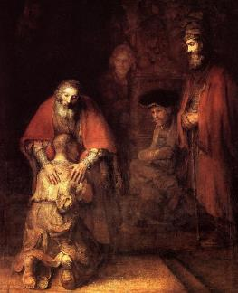
Text: Romans 8:12-17
Title: God, Our Father

Focus: God is our Father, claiming us in Christ
as his children.
Function: that the hearers may pray the Lord’s
Prayer, trusting that they are children
and heirs of God.

Structure: Central Image – Multiple Focus

Sermon Study

Introduction:

I’d like to begin by considering two pictures: one an etching and the other a painting. They are both by the same artist. They are both of the same subject. But there is a world of difference between them.
The artist is Rembrandt and the subject is the return of the prodigal son. In 1636, Rembrandt created a small etching of this scene. Then, 32 years later, he returned to the subject and painted a larger masterpiece, The Return of the Prodigal Son. When you contrast these two studies, one an etching and the other a painting, you notice a world of difference between the two.
In the etching, Rembrandt focuses upon action. The scene is filled with movement. People are descending a staircase. Some are watching their steps, one looks to the side, another looks downward, but all are rushing to join the father who has rushed out before them to lean over and embrace his son. The father, himself, is moving forward. Rembrandt catches him in mid-stride, as he rushes to reach out and grasp his son.
In the painting, however, the picture is different. Here, Rembrandt creates a sense of stillness. He focuses on presence rather than action. No one is moving. Everyone is stationary. And all of the people, whether standing or sitting, are gazing on one central experience. The father, leaning over his son; the son, leaning into his father. These two people, locked in an eternal embrace. It is as if time has stopped and one sees that moment, that eternal moment, when the father acknowledges, claims, receives, blesses . . . yes, loves his son.
This is a moment of sonship. Of being claimed as somebody’s child and Rembrandt sought to capture that moment and freeze it upon your memory.
I begin with that image, because, in our reading from Romans this morning, Paul does something similar. He has revealed to us Christ, our Deliverer. Now, he focuses our eyes upon God, our Father. Rescued by Christ from the power of sin, we are brought into the kingdom of God, where we live by the Spirit as children of God. We are children of God. That’s the main point Paul wants to communicate to the church at Rome and to us today. In Christ, God claims you as his son. God is our Father and we are his children. But what does it mean to be claimed as God’s son?

I. First Focus: Not a Slave but a Son (v. 15-16)

To answer that question, Paul creates a contrast. The contrast between slaves and sons. Paul writes, “For you did not receive the spirit of slavery to fall back into fear, but you have received the Spirit of adoption as sons, by whom we cry, ‘Abba, Father!’” Notice how Paul turns our attention to a moment of prayer. He asks asks the church to stop and consider what happens when we pray. Our words are suspended in mid-air – “Our Father” – and Paul wants us to hear them. Paul freezes that moment and asks us to consider what it means to be God’s son.
If you look closely at Rembrandt’s painting, you can see what this looks like. Rembrandt places the son’s head on his father’s bosom and the father uses his hands to draw the son closer to himself. What is strange, however, is that the son looks less like a son and more like slave. His head is shaven, as if he were a prisoner. His eyes are closed as if he were exhausted. He brings all of his slavery there before his father. And the father reaches down to claim this slave as his son. He hovers over him in love. He places his hands upon his body and draws him to himself. The child brings slavery to his father, but the father brings sonship to the child. This child is no longer a slave but a son, not a prisoner but a child of God.
Henri Nouwen, a priest and devotional writer, once told about a time when he shared this picture with others. For him, the son looked like a prisoner, like the victim of a concentration camp with his head shaven. A woman, however, offered a different view. She looked closely at the painting and told him what she saw. It was not the head of a prisoner but that of a newborn child. With that comment, she captured the mystery of this moment. The one who has been a slave to his passions is made, by the love of his Father, into a son.
This is what the apostle Paul is celebrating in our letter from Romans. By nature, our sinful passions consume us and take us far from the kingdom of God. If we live according to the flesh, we will die. Exiled, imprisoned, thrust far from God’s kingdom. God, however, has brought us to life in the death of his Son. God, the Father, sent his Son Jesus Christ out of love for his people. In dying, Jesus took upon himself the exile of our sin. And, in rising to life, Jesus brings us into the kingdom of his Father. Today, in Jesus, we bring our slavery before God. We confess the ways we have been less than God’s children. The ways we have been enslaved to the experiences and rule of this world. God, however, comes to us in Jesus. He places his hands upon us and draws us near to his heart in love. Today, you are once again claimed by God to be one his beloved children. As Paul writes, “The Spirit himself bears witness with our spirit that we are children of God.” The Spirit cries out with your spirit, “Abba, Father.”
The church has a way of reminding us of this moment. It’s hidden away in our hymnals, buried deep within the minor details of liturgical action, but it is there none-the-less. I’d like you think about two moments in life, captured in the liturgy: the moment of baptism and the moment of dying. In the service of baptism and the commendation of the dying, the pastor does one simple thing. He places his hands on the person, whether that person is being baptized or dying, and he asks everyone who is gathered around that person to pray the Lord’s Prayer. If you were baptized as an infant, you couldn’t say the Lord’s Prayer, but the congregation said it for you. If you are lying there, unconscious and about to die, you cannot say the Lord’s Prayer but again the pastor and the church say it for you. Why?
Because God in this moment is coming and claiming you as his child. In baptism, as you are brought into the kingdom, the church offers you the Lord’s Prayer. This is your prayer, your language to use to speak to God your Father. As you depart this world in the moment of death, the church gathers again to testify that you are God’s. These are your words. God has given them to you as his child. Because you are in Christ, you can call God your Father and nothing, not even death, can take that away from you.
Later in this service, we will pray the Lord’s prayer. I’d like you to think about that moment. This is not just a repetition of a prayer that we say every week. Something to say without paying attention. This is the working of the Spirit. Even now, in our midst. God is reaching out and placing his hands upon you, drawing you close to his bosom, and the Holy Spirit is testifying with our spirit that we are children of God. From baptism to the grave and every moment in between, we cry out “Abba, Father” and rejoice that we are children of God.

II. Second Focus: Not a Debtor to the Flesh but an Heir (v. 12-14 and v. 17)

When Jesus taught us to pray to God, our Father, he also taught us to pray, “Thy kingdom come.” Paul’s words in our text remind us of this petition, as he writes, “The Spirit himself bears witness with our spirit that we are children of God, and if children, then heirs – heirs of God and fellow heirs with Christ, provided we suffer with him in order that we may also be glorified with him” (Romans 8:16-17). Heirs of God. These words are necessary. So necessary in our world.
Daily we are bombarded by messages that try to take God’s kingdom from us. Open any magazine and take a moment to stop and look at the pages. Consider the advertisements. The pictures that draw you away from the things of God to the things of this world. Hair care products and cellular phones, fine clothing and fine food, vacation get-aways and luxury cars. The riches of this world are set on display before you. As you glance through the pages, the life you have seems less significant than the life you could have. With hard work, a bit of luck, a trip to the casino or a shrewd investment in the stock market, you will be able to leave your little life behind and live in the luxury of this world.

Words of God to his people to not covet the things of others, to love one’s spouse and one’s children, to be content with the calling into which you have been called, to rise and labor for the good of others, and to draw near to one another in the household of God – these words, this life, this church that God has made seems so outdated. It pales in comparison to the life that is promised us as we turn another page. America becomes the promised land. The place where we can indulge our desires, make something of ourselves, get ahead in this world, and, if we keep a little bit of religion in our back pocket, trust that we will be blessed in the world to come.
Being a child of God, however, means something other than accomplishing the American dream. Consider a moment in the history of Israel. Moses stood there before God on the mountain. Israel had sinned against God, aroused God’s anger, and God had threatened to destroy his people. Moses interceded for them and God listened to Moses. God, however, offers Moses a strange vision of life for the people of Israel. God says that they can have the promised land, the vineyards, the olive groves, the fields for barley and wheat, the pastures for cattle and sheep, the cities and the open spaces, all of the land flowing with milk and honey. They can have it. All of it. They just will have it without him. God will not go with them into the Promised Land.
Moses, however, puts the magazine aside. He is not tempted by the glossy pictures. He knows that without God, they have nothing. What good is it to gain the whole world and lose your soul? So Moses comes before God with nothing to offer. He simply relies on God’s mercy and prays, “If your Presence does not go with us, do not bring us up from here” (Ex. 33:15). Moses will not have the kingdom without the presence of God.
If you listen to Paul’s words, notice how he focuses upon our relationship to God rather than things in this world. We are heirs, he says. Heirs of God. Not just heirs of a kingdom. We are heirs of God. God himself has promised to go with us. He has called us together as his people and sent us forth to live in this land. Our lives will look different than those of the people around us. We will bless and not curse. We will be content with the calling into which God has called us. We will rise and labor for the good of others and draw near to one another in the household of God. Such lifestyles will not indulge in all the pleasures that America has to offer; such people will not climb the corporate ladder, doing everything they can to get ahead. No, we will be content with what God gives us knowing that, in his kingdom, his presence is enough.
If you look at Rembrandt’s painting of the prodigal son, you will notice that he has frozen the story just at the moment before the son receives all of the tangible gifts from his father. The son does not have a robe placed over his shoulders, he does not have his father’s ring on his finger, he does not have good shoes on his feet. Instead, one foot is bare and worn from suffering in this world. But what the son does have is his father. In the presence of his father, he is led to trust that he shall not want anything else.

So, too, our Lord has called us to live as his people in faith. When Jesus spoke to his disciples, he encouraged them to take up their cross and follow him. Life in this world will not be easy. It will not be filled with the best that this world has to offer. But it will be filled with God’s love. His heavenly Father’s work will continue, after he rises and ascends into heaven, and we have the privilege of being called into God’s mission. We are the children of God, at work in our Father’s kingdom, bringing salvation to the ends of the earth.
Notice how Paul closes this section of the text. He writes, “we are children of God, and if children, then heirs – heirs of God and fellow heirs with Christ, provided we suffer with him in order that we may also be glorified with him” (Romans 8:16-17). Paul calls to mind the suffering of Christ. We follow his way in this world, suffering with Christ, knowing that ultimately we will be joined to him in glory at the revelation of God’s kingdom. We are heirs with Christ. Children of God.

Conclusion:

I mentioned earlier that 32 years had passed between the first and last times Rembrandt worked with the prodigal son. Much happened in Rembrandt’s life during those 32 years. He lost his wife, his wealth, three of his four children, and his reputation. He then lost his last and only surviving son. “In the world, you will have tribulation,” our Lord says, “but take heart; I have overcome the world” (John 16:33). After losing all that our world would say gives life meaning, Rembrandt chose to focus upon the one thing that Jesus gives that this world cannot take away. The Spirit of adoption.
God, the Father, claims you as his child. Jesus makes us children of his heavenly Father. We bring our slavery to sin before God and in Jesus we are forgiven. Our fears are silenced and our future is secure. We are made children of God. Children and heirs. Heirs of a new world and a new kingdom to be revealed when Jesus returns, but more importantly, heirs of God himself. The apostle Paul paints the picture for you this morning in his letter to the Romans: God the Father claims all of you as his children. He loves you, forgives you, embraces you, and claims you as his people, because of the life, death, and resurrection of Jesus his Son. Amen.

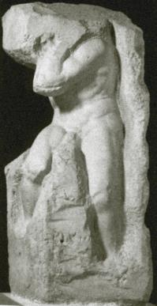
Date: Proper 11 (July 20, 2017)
Text: Romans 8:18-27
Title: Holy Spirit, Our Intercessor

Focus: The Holy Spirit knows the mind of God and
intercedes for us according to God’s will.
Function: That the hearers may live with hope in the
midst of suffering.

Structure: Central Image - Multiple Focus

Sermon Study

Introduction: Seeing the Spirit of God

In this sermon series, we have been looking at the big picture. The greater story of the presence and work of the Triune God. We have seen Christ, our Deliverer, rescuing us from our sin. We have seen God, our Father, claiming us as his children. Today, we see God, the Holy Spirit at work in our lives. To see the Holy Spirit, however, requires a wide-angle lens.
In Psalm 139, the psalmist asks, “Where shall I go from your Spirit?” In answer, he meditates on the places he might go. If he goes up to the heights of heaven, God’s Spirit is there. If he goes down to the depths of Sheol, God’s Spirit is there. If he goes to the farthest parts of the sea, even there God’s Spirit guides him and holds him fast. The Spirit of God overwhelms the psalmist. He sees the Spirit every place he goes. And so it remains for God’s people today.
Look to the heights of heaven and you can see the Holy Spirit. In Genesis, the Spirit of God hovers over the face of the waters. High in the heavens, the Holy Spirit hovers. Time begins and creation takes shape. Look to the farthest reaches of the sea and, again, you can see the Holy Spirit. The disciples gather together for prayer in a house in Jerusalem and suddenly the Spirit does more than hover over the world; he descends into it, in a flash of flame and the wildness of wind. He fills mouths with speech and hearts with wonder, clothing God’s people with power from on high and sending them forth in mission to the ends of the world. In the highest heavens you can see the Spirit. In the farthest seas, you can see the Spirit.

Today, however, as we contemplate Paul’s letter to the Romans, I’d like to take you to one more place. Not the highest heavens and not the farthest seas. No. The place to which I’d like to take you is a hallway. A hallway in Florence in the Galleria dell’Accademia. Here, voices are hushed and sounds are silenced. There is little to hear in this place. But there is much to see.

I. First Focus: A Moment Frozen in Time

This hallway is part of a museum and, as you stand there, you are surrounded by four unfinished pieces of stone. It is as if time itself has been frozen. An artist was working but stopped in the middle of his work, leaving four pieces of marble. The edges are rough. The stone is misshapen. These rocks look like they have been cut from the quarry and dragged to this place. And yet, emerging from these blocks of stone are the beginnings of figures. Some have no faces. Others are missing arms, hands, feet. Yet you can clearly see the beginning of four figures. They are slaves. Prisoners. Begun by Michelangelo but never finished. His work has been frozen in time. What they once were, rough blocks of marble, is gone. What they will be, beautiful sculptures, is not yet here. Instead, we stand here in the hallway in the midst of an awkward moment. The past is gone and yet not gone. The future is here and yet not here. We can see the future, slowly taking shape, and yet the past is painfully with us, as figures appear before us locked in the stone.
In our text this morning, Paul invites us into a hallway like this. He asks us to see how we are caught right now in the middle of God’s greater vision and work. Paul begins by saying, “The sufferings of this present time are not worth comparing with the glory that is to be revealed to us” (Rom. 8:18). Suffering and glory held together in this moment. Like rough hewn stone, our present world is filled with suffering. God had originally formed a beautiful creation. Wherever one looked, one could see God’s fingerprints and it was beautiful and it was good. Adam and Eve, however, brought suffering into God’s creation. They disobeyed God and brought God’s curse into the world. “The day you eat of it, you shall die,” God had said and now God came and subjected the beauty of creation to the bondage of decay. Such punishment was set in stone and only God could free his creatures and bring about a new creation. This is the glory that Paul has seen in Jesus Christ. The beginning of a new creation. The beginning, just the beginning of eternal life. Like first fruit foretelling a future harvest, Jesus Christ is the promise of a new and never-ending life. God has begun his work, and like this glimpse of figures in stone, it is only a matter of time before the full glory of God is revealed.
So Paul writes to the Romans to help them stand in this painful moment. And his words come to us to help us stand here today. In Christ, we have been made into the children of God. This is sure. This is certain. His death has destroyed the power of sin for you and his resurrection has brought you the promise of a new creation. Yet what we are is not fully seen and experienced in this world. Take a deep close look at God’s people, Paul says, and you will see a people, imprisoned and suffering, groaning because they desire to be free.
So we stand, awkwardly positioned between the sufferings of this present world and the glory yet to be revealed. And in this place, the apostle Paul asks us to meditate on our situation and to trust in the work of the Holy Spirit.

II. Second Focus: Meditating on Our Situation

To meditate on our situation is like taking a good close look at these figures in stone. If you look closely, you will see that each of the figures Michelangelo carved is different. One is young. Another is older and bearded. One slowly awakens and another is busy working, bearing his burden in the heat of the day. While each of them is different, one thing remains the same. All of them are slaves. Young or old, working or sleeping, all are slaves in the eyes of this world.
So, too, for God’s people. If we meditate on our situation, we can see deep suffering among God’s people. In America, Christianity used to be a strong cultural force. Prayer was said in public schools. At graduation, high schools would hold baccalaureate services led by ministers. In December, one could find a nativity prominently displayed in the public square. That connection between Christianity and American culture is dying. We find ourselves being marginalized. Pushed further and further away from public notice, written into a smaller and smaller corner of the public square. Such experiences are frightening. It looks like we are losing strength, like we will not survive. Some might even wonder if God has abandoned us. Unfortunately, some American Christians have confused the power of God with the powers of this world. To them, the strength of God and his church are directly related to the strength of America as a Christian nation. Now, as American culture turns against Christianity, Christians can begin to wonder about the love and blessing of God. Has God abandoned his people? How can we be God’s people, the church, in a non-Christian nation? To such a situation, Paul’s words offer hope. Listen to the apostle Paul for he offers you, today, God’s love and blessing in this letter.
Paul knew the suffering status of Christians in this world. In Rome, Christianity was not a legal established religion. It confronted barriers to the expression of its faith. Christians sought to worship one God in a city that had many gods. Christians sought to confess “Jesus is Lord” in a city that confessed “Caesar is Lord.” Christians worshipped a person who had been associated with insurrection, was publicly tried and condemned and crucified. This suffering Jesus ruled over a suffering people. Christians were marginalized. Pushed off to the side. They were meeting in small homes rather than huge and beautiful churches. They were populated by slaves rather than powerful rulers. Soon, they would experience persecution. They would carry their dead into caves and tunnels carved under ground and hold worship services there in the dark, in the place of the dead.
“If I make my bed in Sheol,” the psalmist cries, “You are there.” When persecution shoves you into the darkness of death, into that place where you open your eyes but you cannot see God, God is there. That is Paul’s message. The Spirit of God is there, even in the darkest places of death. Open your ears and you will hear him. You will hear the Spirit of God, crying out in this place with you. Crying out for you.
This is what Paul is revealing to the church in this letter. The Spirit of God cries out for God’s people. The world is groaning as it awaits the revelation of the sons of God and the new creation. God’s people are groaning as they are locked in positions of slavery and rejection by this world. But the apostle Paul reveals one more thing. He opens our ears so we hear one more groan. The groaning of the Spirit, who is interceding for you.

III. Third Focus: Trusting in the Work of the Spirit

Paul writes, “Likewise, the Spirit helps us in our weakness. For we do not know what to pray for as we ought, but the Spirit himself intercedes for us with groanings too deep for words. And he who searches hearts knows what is the mind of the Spirit, because the Spirit intercedes for the saints according to the will of God” (Romans 8:26-27). In these words, Paul joins groans with a glorious vision.
On the one hand, the Spirit intercedes for us with groans too deep for words. There are times when we are at a loss for words. The suffering we have seen in this world, the longing we have for the new creation is so strong and so deep that we cannot find words to express it. What do you say when you go to a child’s funeral? You stand there, next to her parents, your heart filled with groans that words cannot express. What do you say when your wife tells you the doctor said it was cancer? How do you respond when an earthquake strikes in Haiti, a hurricane in New Orleans, a terrorist in New York? The broken edges of this fallen world cut deep and language itself is limited. It is too short to reach down and touch our sorrow much less grab a hold of it and put it into words. We have trouble speaking to one another, and even more trouble speaking to God. At moments like this, Paul asks us to listen. To hear the groaning. The Spirit takes our suffering and puts it into prayer.
The groans of the Spirit, however, are joined to glory. The glorious desires of God for his people. For all creation. You know, one of the interesting things about Michelangelo’s unfinished sculptures is how he approached carving figures into stone. Michelangelo believed that his work as an artist was to liberate figures from the stone. Rather than carving figures into stone, he saw himself as freeing these figures from the marble. Though his work is unfinished, we can catch glimpses of his larger vision, his master plan. The larger glorious vision of these figures was there in the mind of the artist and, only through time and effort and the removal of stone, piece by piece, did that vision slowly come into being.
In a similar way, Paul talks about the glorious vision of God seen by the Holy Spirit. Paul says that “the Spirit intercedes for the saints according to the will of God” (Rom. 8:27). The Spirit knows not only the deep mysteries of our suffering. The Spirit also knows the deep mysteries of God. God’s vision of a new creation. You have been joined by baptism to God’s new creation in Christ. God is at work in him. He is shaping our lives, forming our faith, working in small and sometimes painful ways as he continues his promise to bring about the kingdom. We cannot see this plan of God. We cannot see his overall design. Sometimes, we can’t even see the smallest carvings he does as he leads this world to that day of the new creation. But the Holy Spirit is our Comforter and Counselor. The Spirit knows the mind of God and the Spirit knows the suffering of God’s people. And, as Paul proclaims, the Spirit joins these two into prayer. Groans and glory are held together by the Spirit for us in prayer. When we stand before God, frozen in time, living in this world and yet sure of another. When we experience suffering and find ourselves not sure how to put all of this into words, the Spirit himself speaks for us. He brings our petitions to the throne of the Father. Our suffering touches God’s glory in the words of the Spirit and we trust his work because of God’s love made certain for us in the death and resurrection of his Son.

Conclusion: Living in Hope

I invite you one more time into the hallway of the Galleria dell’Accademia. Note that these sculptures are displayed in a hallway, not a closed room. This space is a corridor where people pass from one place to another and, at the end of the hallway, stands a work of remarkable beauty, Michelangelo’s David. No longer is this figure a slave encased in stone, but now he stands, in glorious freedom, the freedom of a man of God.
How much greater is that glory of David’s son and David’s Lord. Our Lord, Jesus Christ, the Ruler of a new creation. In him, God the Father will bring all things to completion. He is the one who stands there, ruling over all at the end of this world and the beginning of the new creation. Paul can barely see this, but he knows that it is there and so he offers us hope. Hope that lives and breathes through the prayers of the Spirit. Although we suffer in this world, we are heirs of the next. The Spirit knows the mind of God and he hears our cries and prays for us according to God’s will. Christianity may be losing cultural power in America, but it is not losing spiritual force. God is alive. He rules over all creation. He sees your life, he knows your suffering, and he has sent his Spirit to be here for you. He listens to your groans, he sees God’s greater vision, and he puts your life into prayer according to God’s will. So, wherever you go in this world, you are never far from the Spirit. At home, at work, falling asleep or rising for labor, the Spirit sees and intercedes for you according to the will of God. Amen.

Date: Proper 12 (July 27, 2014)
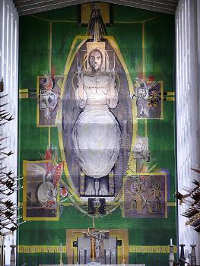
Text: Romans 8:28-39
Title: God, in Love, Ruling over Ruins

Focus: Christ rules in love over the ruins of this
world.
Function: that the hearers may receive the
body and blood of Christ in hope.

Structure: Multiple Image Design

Sermon Study

Introduction: Christ Enthroned in Glory

If you go to Coventry Cathedral and stand before the altar, you will be overwhelmed. Overwhelmed by the tapestry that rises above you. The scene is Christ enthroned in glory. A pale and wounded Christ is seated on a throne. Surrounding him is a band of gold that branches out into four corners. And in each corner is a symbol of one of the evangelists. These four evangelists give us one vision: a vision of the wounded Christ ruling over the fallen world. The sheer size of the tapestry makes it overwhelming. It is about the size of a tennis court, hanging in the air. It took 12 weavers 3 years to complete. And yet this woven picture of Christ, enthroned in glory, hanging above the altar, overwhelms in another way. It overwhelms us with God’s love.
What Graham Sutherland did with thread in this tapestry is what the apostle Paul does with words in his letter. This morning, we consider one of the most beautiful passages of Paul in Romans. A time when he has woven together all of God - Father, Son, and Holy Spirit – with all of creation – death and life, angels and demons, present and future, things seen and unseen. All of God rules over all of creation in love. That’s what the apostle Paul wants us to know. Paul takes us to the end of the story of God, which is really not an ending at all but a new beginning, a glorious re-creation of all things and the final victorious revelation of God’s people as more than conquerors in his love.
Yet when we read the words of the apostle Paul, something interesting happens. It is not as if we are standing there, at the foot of this tapestry, looking up at an overwhelming figure. No, it is as if Paul has invited us upward so that we are with the figure of Christ in the tapestry and, from there, has asked us to turn around and see what Christ sees. Paul wants us to see the world through the eyes of Christ for he knows that that vision will change your life.
So often, when we come to church, we come with a limited vision of God. We look at God through the experience of our lives and that limits what we see. Did he answer my prayers this week? Did he give me strength to deal with work? To handle the kids? God can become small. Small enough for us to fit him into our lives. Once a week. On a Sunday. Whereas Paul wants to change our perspective. Paul wants us to experience a reversal. We don’t fit God into our lives. No, God brings us into his life, his love, his rule of the world. Paul asks us for just a moment to see the world through the eyes of Jesus, risen from the dead and ruling in love. So, this morning, let the apostle Paul raise your eyes and your hearts to see the world through the eyes of Jesus. Let Paul bring you to God, in love, ruling over ruins.

I. The Ruins of This World:

Ruling over ruins. That is what Paul helps us see this morning. God in love is ruling over ruins.
Paul’s words remind us of the ruins of this world. The ruins outside the Christian and the ruins within. Paul names those things people fear would separate them from God. Tribulation, distress, and persecution. Famine and nakedness. Danger and sword. And these are not just words for the apostle Paul. No, Paul is naming the reality of what he has seen in his ministry. He himself is journeying to Jerusalem, carrying a gift for the poor who are suffering under famine. Paul has been in prison. He has suffered tribulation and danger. He knows how the world fights against God’s people. The evils, however, are not only those that stand outside the Christian. Paul knows there is evil that flows from within. He himself stood there as Stephen was stoned and he approved of his execution. So Paul knows this hatred and abuse from the inside. He himself could easily stand there, guilty before God, accused of his sin.
In this section of his letter, Paul invites us to bring it all before God – the evil that stands outside of you, the forces that threaten to destroy you, the loss of a job, the death of child, the tragedies you know you will never get over. Paul invites you to bring these before God. But he also asks you to be honest about the evil within. We stand before God, suffering from a world in ruins but also suffering from our own sins. The distance that lies between you and your son, the anger that brews between you and a co-worker, the greed that causes you to turn a blind eye to others in need. Paul asks us to bring this all before God, the evil without, the evil within, to gather it up and place it before his throne, sure that there is not enough time nor enough space to hold all of the evil and suffering we bring. Paul asks us to bring that before God because Paul knows what God in Christ is bringing to us. Love.

II. God Ruling in Love:

While we bring all of our evil before God, God brings all of his love to us. This is Paul’s insight. Paul knows that God is ruling over the ruins of this world in love.
If you were to go to Coventry Cathedral and stand there, below the tapestry, looking away from it, toward the church, it is amazing what you would see. As Jesus looks from the tapestry, he sees a church in ruins. Coventry Cathedral is a church built upon ruins. On November 14, 1940, the city of Coventry was bombed. It experienced the blitzkrieg, the nighttime horror of Hitler’s Luftwaffe in World War II. In one night, this cathedral, this place where people had worshipped for almost 900 years, was reduced to charred wood and ruined stones rising from the earth in columns of smoke.
Jock Forbes, a stonemason at the time, looked over the ruins and saw two medieval timbers, charred from the fire, and fallen to the ground in the shape of a cross. They took these timbers and placed them, as a cross, on top of a pile of rubble, making an altar before a wall of shattered stones. Behind them, they placed the words, “Father forgive.” Then, a new cathedral was built extending off of the old ruins. This tapestry hangs at the altar of that new cathedral. From it, Jesus sits enthroned, facing the ruins of a fallen world. There, in front of him, are the seats where people gather. But behind the people are the ruins of the old cathedral. Separating the people from those ruins is a wall of glass. On it are etched images of angels and saints. Figures from the Old Testament, from the New Testament, from the martyrs of the past and the present. Jesus, enthroned in glory, looks out over a fallen world. His vision, however, is one of hope. He sees the angels and archangels and all the host of heaven. He sees the saints and the prophets, the apostles and martyrs, the ways in which his church has triumphed in the midst of suffering. And through that glass, in the midst of the ruins, are the charred remains of a cross, a place where God’s love was made visible to all people.
This is what the apostle Paul sees and wants to share with you today. Christ sees you, living in a world ruined by the fall. You live among wars and rumors of wars. At times, you are victims of suffering. At other times, however, Christ sees that you are evil toward others. This world would ask us to give up, to clear away the ruins, to forget about God and about this suffering and sin, and go on. And many try to do that. Yet, Paul invites you to stay. To stand in the midst of all of this and to stand before God, in your sin and suffering, known and unknown. Why would Paul ask you to do this? Because Paul knows the one who rules over all. Jesus. And Paul knows that this Jesus who sees all has given all of himself for you.
At the heart of it all suffering and sin is that charred cross, that moment of our redemption, when Jesus Christ offered his sinless life for our sinful flesh. Through his death and resurrection, Jesus defeated the powers of sin and hell and death itself and claimed us as his own. God is for you. In Christ. Listen to Paul. He asks you, “Who shall bring any charge against God’s elect? It is God who justifies. Who is to condemn?” Here, can you hear the note that Paul sounded earlier in his letter? Earlier he said, “For all have sinned and fall short of the glory of God, and are justified by his grace as a gift through the redemption that is in Christ Jesus” (3:23-24). Now, Paul lets this note echo in the space of all of creation and it forms an overwhelming symphony of grace.
From that one note, the sound grows louder and, like the new cathedral joined to the old, the vision grows larger and more glorious. Paul sees not only the heart of this love but the breadth of it all. God’s love spans our entire life, as Paul writes, “for those whom he foreknew, he also predestined . . . and those whom he predestined he also called, and those whom he called, he also justified, and those whom he justified he also glorified.” Then, Paul sees not only the breadth but also the height and depth of this love. Not only has Christ died and risen for us, not only does Christ hold our entire life in his hand, but Christ also rules over all of creation in love so that Paul can sing a never-ending song. He begins by saying, “all things work together for good for those who love God and are called according to his purpose” and he closes by saying, “I am sure that neither death nor life, nor angels nor rulers, nor things present nor things to come, nor powers, nor height nor depth, nor anything else in all creation will be able to separate us from the love of God in Christ Jesus our Lord.”
Paul knows that we are immersed, daily, in a ruined creation, but he asks us for a moment to lift our eyes and to see this vision of Christ enthroned in glory. It is a vision that gives us hope.

II. We live before God in hope:

And hope is a hard thing, a very hard thing to live in. Think about the cathedral. After the Coventry Cathedral had been bombed, it would have been easy for the people to do one of two things. They could have looked at the ruins in despair. Given up and walked away. Or they could have cleaned up the ruins, erased their memory, and built a new church where no one would even know the difference. One option lets the destruction triumph and denies any hope of a future. The other option lets the future glory triumph and denies that suffering is real in this world. What they did, however, was something different. They held the suffering and the glory together in a vision of hope. They didn’t walk away from the church, defeated by suffering, but built a new one. Yet, they didn’t clear away the ruins and build on top of them. Instead, they left them as a reminder of suffering in this world. The ruins and the church stand together as a visible reminder that in the midst of the fallen creation God continues to rule in love and his rule gives us hope.
What happened at Coventry Cathedral decades ago happens in our lives every day. Every day, we are confronted by the suffering of our world and the sins of our flesh. Listen to the news; you can hear the suffering. Look at your heart; you can see the sin. For some, the temptation is to despair. They are tempted to give up, to lose hope, to believe that God has not conquered and to try to fend for themselves. For others, the temptation is to a foolish hope. They take a passage like this one from Romans, and use it to dismiss the very real pain and anguish of suffering. “All things work together for good,” they say, and it doesn’t matter whether they are speaking to a mother who has lost her son in a drunk driving accident or a father who struggles to raise his children after a divorce. “All things work together for good,” they say, and yet their words don’t recognize the real pain and evil in front of them. Christian life in this world is neither of these options. It is actually a paradox – a strange combination of glory and suffering. We are certain of the glorious future that God has in store for us, we know and trust that all things work together for good, but we also see the reality of suffering in this world and are moved to sorrow and compassion for those in the midst of it. Seeing the ruins of this world, we do not give up hope. And seeing the hope of the future, we do not deny the suffering of this world. No, instead, we live in both worlds – in the reality of suffering and in the certainty of hope.
At the foot of this tapestry is an altar and, when you draw near to that altar, you experience this reality of suffering and hope. The closer you come to the tapestry, the harder it is to see Christ, high above you, ruling over all. What you do see, however, is what the artist placed at the very bottom of the tapestry. A picture for those who would dare to draw near. At the very bottom of the tapestry, where it draws closest to the earth, is a depiction of the cross. There is Christ crucified for all people. And his figure is seen most clearly when you come forward for communion. There, as you go to the altar to receive the body and blood of Christ, you experience both the reality of suffering, God’s suffering for us, and the reality of hope, God’s rule for us, in Christ.
We gather today at an altar without that tapestry but we gather with the body and blood of our Savior. What the artist created with threads, what Paul created with words, we remember with song. Consider the hymn of praise in our hymnal. “This is the Feast of Victory,” we sing. Imagine what this must look like to those outside the church. If those outside the church looked in, they would not see a feast. All they would see was a small amount of wine and thin wafers of bread, a mere taste given to the people. Yet we sing, “this is the feast.” If those outside the church looked in, they would not see victory. They would see people. Suffering people. We experience the same difficulties as others in the world. We are not immune to cancer, to mental disorders, to depression, to death. And yet, we sing, “This is the feast of victory.” Why? Because we know that the victory of God has come to us in Jesus Christ. He is now present with us in his body and blood. Suffering and hope brought together here for you in love. He has triumphed over sin, death, and the devil and he rules over this world in love. Though we don’t see him now, enthroned in glory, we know of that new creation and we rejoice in this Jesus, this one who gives us his body and blood and rules over us in love.

Conclusion:

And this love of Christ continues, long after our feast and song is over. The apostle Paul reminds us that “Christ Jesus is the one who died – more than that, who was raised – who is at the right hand of God, who indeed is interceding for us.” Jesus is interceding for us.
Often when artists depict Christ enthroned in glory, they show him seated on a throne with one hand raised in blessing. That is not what you see on this tapestry. Instead, you see Jesus, sitting with both hands raised upward in prayer. This Jesus who died and rose and rules over all things intercedes for you. As you make your way home, as you enter into another week, he continues to pray for you. Jesus takes your suffering and burdens, your sins and sorrows, and presents them in prayer to his Father. Nothing you encounter, nothing you bring, can ever separate you from God. Neither death nor life, nor angels nor rulers, nor things present nor things to come, nor height nor depth, nor anything else in all creation will be able to separate us from the love of God in Christ Jesus our Lord. We are more than conquerors in Jesus who rules over these ruins in love. Amen.

Date: Proper 13 (August 3, 2014)
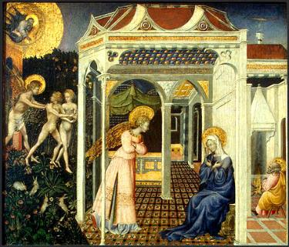
Text: Romans 9:1-5 (6-13)
Title: People of the Promise

Focus: God has joined us to a people
who live by his promise.
Function: that the hearers would rejoice
in being joined to the people
of God.

Structure: Image Delayed

Sermon Study
Introduction:

You may have seen it before, on a laminated card in a Christian bookstore or on the back page of a bible in a hotel room. It’s a listing of passages to look up in the bible when you are in need of a word from God. On the left hand side of the card are different situations in life. “When you worry . . . when you feel alone . . . when you struggle with temptation . . . when you have financial trouble.” Then, on the right hand side of the card are the passages that you should look up for each situation. So, “When you are worried” you are directed to look up 1 Peter 5:7 and there you read, “Cast all your anxieties on God, because he cares for you.” It’s a quick, easy way to find a bible passage that speaks to you. The last thing you want, when a person is worried, is for her to open the bible and read about God striking Ananias and Sapphira dead in their tracks or God sending bears to kill 42 children for mocking the prophet Elisha. It’s much safer to open the bible to one single verse, pre-selected, and begin reading there.
While this listing of passages can indeed be comforting and has brought many people a word from God who otherwise would be lost when they open the bible, the difficulty is that sometimes people never get beyond this kind of reading of the bible. They open the pages. They find a comforting word. But then they set the bible aside and they never find themselves entering through this door into the deeper, richer story of Scriptures.
Christianity becomes something it was never intended to be. A private, personal religion. It becomes something you turn to not when you enter the world but when you retreat from it. It’s something you read in your private devotional time and you look forward to that moment when it is “just me and Jesus.” God becomes something like our best friend, a person who supports us when times get tough, and someone who helps us accomplish our plans and fulfill our dreams. The problem, of course, is that we have reversed roles with God. Rather than us being servants in God’s kingdom, God becomes a servant in ours. Rather than us being brought into God’s greater story, God is brought into ours.
In our sermon series, we have turned our attention to God’s greater story and we have seen the main actor in that story – not us, but God. God is the one who was there at the beginning, creating this world and all of the cosmos; and God is the one who will be there at the end, bringing about a new and glorious recreation. In between the beginning and the end, God is here, Father, Son, and Holy Spirit, working in love and ruling over ruins. At this point in the sermon series, we are going to see how God’s greater story involves a greater people, God’s greater people. While God certainly is present there for every individual person, able to be found in a small bible passage a person reads when lonely in a hotel room, God’s vision is much greater than that. God has come in Jesus Christ not only to save you and each person in the entire creation but also to join you to a people, a people who live by his promise and for his purpose in his kingdom. This is what the apostle Paul reveals in our text and this is what God calls us to rejoice in today.

I. Text: Paul’s Prayer and the People of the Promise

As you listen to our text this morning, you realize that we have come across Paul in a very private moment. Paul is engaged in prayer. His prayer is powerful and personal and very very painful. I don’t know if you have ever come before God on behalf of someone you love, someone you care about, and yet someone who will have nothing to do with the faith. You love that person. You know that God loves that person. And you know that God would desire that person to be saved and yet that person wants nothing to do with God. And so you stand there, alone, not because you don’t believe in God. You believe in God. But you are alone because you stand there without your friend, your mother, your son who has walked away from the faith. If you have ever been there, you have a very small clue of what the apostle Paul is experiencing. This is a very private moment. A very personal and painful prayer.
Paul cries out, “I am speaking the truth in Christ – I am not lying; my conscience bears me witness in the Holy Spirit – that I have great sorrow and unceasing anguish in my heart. For I could wish that I myself were accursed and cut off from Christ for the sake of my brothers, my kinsmen according to the flesh.”
Paul is concerned about his brothers, his kinsmen, the Jewish people. Five years ago, the Jewish people had been expelled from Rome. The Emperor Claudius was attempting to maintain law and order in the city. There had been civil unrest and so he acted as previous emperors had done (Tiberius in 19 AD) and expelled the Jews from Rome. The expulsion was limited to the Jews and the expulsion was limited to Rome. When Claudius died, his expulsion died with him. The Jewish people were now returning to Rome and yet, the question was, how would the church receive them? What had begun as a movement of faith among the Jews was now predominantly Gentile. The Jews had left but the church had remained and grown with Gentile believers. Paul was worried, not only about the Jews who did not believe but also about the Gentiles who may not see any reason to care about the Jewish people.
Earlier in the letter, Paul asked a very important question. As he revealed that all have sinned and fallen short of the glory of God, Paul asked, “Then what advantage has the Jew?” We would expect Paul to say, “none.” That is, “all are sinful and all are justified by grace through faith in Jesus Christ.” Therefore, there is no advantage to being a Jew. But, surprisingly, Paul says something different. “What advantage has the Jew?” Paul asked. His answer was “much in every way. To begin with, the Jews were entrusted with the oracles of God.” That listing that Paul began in Romans 3, he continues now in Romans 9. Listen as Paul reveals the blessings of God upon Israel: “They are Israelites, and to them belong the adoption, the glory, the covenants, the giving of the law, the worship, and the promises. To them belong the patriarchs and from their race, according to the flesh, is the Christ who is God over all, blessed forever. Amen.”
Paul is engaged in a moment of prayer, very personal and very private, and yet notice how his prayer is wrapped up in the larger story of God. Paul is not praying for himself but for God’s people. Paul is not setting before God his day and his plans and asking for God’s blessing. No, Paul finds God’s greater story set before him and is praying for fulfillment of what God has planned. God has chosen Abraham to be the father of his people and from Abraham God has chosen to bless not only his people but all nations on the face of the earth. From Abraham and his descendents, according to the flesh, comes Christ and Christ is the one in whom Israel and all nations of the earth are blessed. Paul knows this greater story of God and this story shapes Paul’s life and prayer.
What is amazing is that Paul in prayer is caught up in the heart of God’s story. Notice how Paul is willing to die for the sake of the Jews. Paul knows that not all of his Jewish brothers and sisters have believed in Jesus. Because of the expulsion of the Jews from Rome, it would be very easy for the Christian church to become a Gentile church, that does not see or value or care about Israel. And so Paul finds himself overwhelmed with pain and personal love and he wishes that he himself could be cut off from Christ, if that could save the Jewish people. Here, Paul’s heart is filled with the love of Jesus. Jesus is the very one who was willing to be cut off from God, who was willing to drink the cup of his Father’s wrath, who was willing to be forsaken by God and condemned to hell, that the kingdom of God might be opened to all people who trust in him. In him is forgiveness, life, and everlasting salvation. In him is the promise that your sins are forgiven and that you are now part of the people of God, people who live by that promise as part of God’s greater story.
This is what the apostle Paul is doing in his prayer. He is living by that promise, letting God’s greater story, God’s greater vision, shape his prayer and his life in self-sacrificial love.

II. Application: Our Lives as People of the Promise

How does this relate to us today? Consider how Paul reminds us that we are part of a greater people brought into the greater story of God. Sometimes we can lose sight of this larger story. Faith can become a personal matter, something that we reduce to a private experience to help us get through the week. Paul awakens us this morning to the fact that we are part of a people, a much greater people, who live by the promise of God.
A Lutheran pastor once took part in an evangelism experience in Israel. He worked with a leader named Bodil from the Caspari Center in Jerusalem. Their work focused on supporting small communities of faith among Jewish people in Jerusalem. At one point, the pastor listened in as Bodil talked with a Jewish woman who did not believe in Christ. The woman asked Bodil why she was so concerned. “After all, you have your bible and you have your Jesus and I have my Scriptures and I have my God. Why do I need to believe in your Jesus? Why can’t we both just believe in God?” Bodil looked at the woman and she said, “If my Jesus isn’t your Messiah, then I don’t want him. Your Scriptures are my Scriptures and your God is my God,” she said. “And if Jesus is not your Messiah, then I don’t want him and I will wait for the one God has promised.” The pastor was surprised by Bodil’s answer.
For years, the pastor had looked at the Old Testament Scriptures as helpful for proving that Jesus was God. He would pick and choose among passages – Isaiah 9, “to us a child is born” or Isaiah 53, “he was wounded for our transgressions, crushed for our iniquities” – and help people see how these passages talked about Jesus. But, when it came down to it, he was much more comfortable reading the New Testament. The Old Testament was helpful for pointing to Jesus, but he’d much rather focus on the gospels and the epistles of Paul. Sermons rarely worked with the Old Testament. Bible classes were the same way. How strange then to hear Bodil’s answer. Bodil started with the Old Testament. These were her Scriptures. These were her words from God. And if Jesus didn’t fulfill these Scriptures then she would hold on to the Old Testament and wait for the Messiah God promised.
While the woman Bodil talked to did not come to the faith that day, the pastor who overheard her was brought to a deeper belief. He began to see how God had brought him into a much larger story. It was the story of God’s work through a people in this world. This God who created all things called forth a people. To them he gave promises. To them he sent prophets. And now, this pastor, in Christ, was part of this people in the body of Christ, the church. The prophets were not simply books he turned too looking for a passage that he might relate to Jesus. Rather, now, he began to read them and see the larger vision and glory of God. Yes, that vision was centered in Jesus but it was much richer and fuller than the pastor had known.
Consider the Old Testament reading this morning. God’s call to his people to come and eat. This is more than a foretaste of the feeding of the 5,000. This is part of God’s eternal vision of a banquet for all peoples. God speaks of an everlasting covenant made with David. He is a witness and leader and commander for the peoples. Through him, Israel will call nations they know not and nations that did not know them will run to them. Suddenly, we begin to see a much larger table and a much greater feast for all people and all time. We begin to overhear God’s promises throughout the Old Testament to feed and care for his people. From the manna that falls from heaven to the rocks the flow with water in the wilderness, from the table that the Lord our shepherd prepares to the teaching that “man does not live on bread alone but on every word that comes from the mouth of the Lord” to the table that wisdom sets for her people. This banquet lies behind the banquet parables of Jesus and this banquet, this eschatological feast in the kingdom of God, lies ahead of all of us, as part of God’s people, gathered from all nations, who live by the promises of God. Rather than open the bible and try to use God in our lives, we find that God opens the Scriptures and brings us into his story and the life of his people in this world.

Conclusion:

There is a painting that captures what this looks like. It used to be there on an altar in Sienna. It was one of five small paintings at the very bottom of the altarpiece. You normally wouldn’t see it if you were seated further back in the church. If you came forward, however, for communion, you could see this small painting of a moment in the work of God for this world.
The painting was of the annunciation. That moment when Mary received word from the angel Gabriel that she was chosen to bear the Savior. Mary is seated, alone, in a room. There is nothing in that room to distract her. In fact, she could easily have been at prayer. Before her stands an angel, Gabriel, bearing a message from God. When you look at the painting closely, however, there is something amazing. Rather than paint the scene realistically, the artist has taken this story and placed it in a much larger story of God’s work in the world. As you look outside the house where Mary is sitting, you see a garden. This is not any garden, however. It is the Garden of Eden. The artist has taken Mary and this house where she is praying and placed it on the edge of the Garden of Eden. There, outside her window, are Adam and Eve. The scene is a sad one. You see God the Father banishing Adam and Eve out of the Garden. They have sinned against God and brought his wrath upon all of creation and now they are subject to death and must live in a fallen world. As God the Father extends his arm to banish them from the garden, however, something beautiful happens. If you follow God’s arm, you see that God is pointing from that Garden to the Virgin Mary sitting in this room. God sends Adam and Eve out of the Garden but he does so with a promise – that there will come a day when the woman will have an offspring who will bruise the head of Satan and rescue his people from sin.

Adam and Eve and all of those who lived after them, Abraham and Isaac and Jacob, David and Solomon and Isaiah and Malachi, were people of this promise. And now, here in this small room, in this private moment of prayer, God brings Mary into this story and in her words of love and self-sacrifice, “Behold I am the servant of the Lord; let it be to me according to your word,” God continues his greater story of bringing about salvation in this world. Mary in that moment of prayer did not try to use God as a servant in her plans. No, she humbly offered herself as a servant in his. Her private prayer was a moment when God brought her into the story of his people. It was true for Mary. It was true for the apostle Paul in Romans. And it is true for you, this day. As you come to this altar to receive a foretaste of God’s eternal feast, come rejoicing that God has chosen to bring you into his larger story, to be part of a people who live by his promise and, with self-sacrificial love, seek to serve him in the world. Amen.

Date: Proper 14 (August 10, 2014)
Text: Romans 10:5-17
Title: People with a Purpose

Focus: God has joined us to a people
who live for his purpose.
Function: that the hearers would
experience the wonder
of God’s mission.

Structure: Central Image -Multiple Focus

Sermon Study

Introduction:

In 1961, a visitor walked into the Kelvingrove Art Gallery and Museum in Glasgow . . . carrying a brick. He found a painting of the crucifixion and started to destroy it. His anger . . . his violence . . . his desecration of Christian art was not done out of hatred for Christianity but out of love for Christ. He objected to the way the artist had portrayed the crucifixion of Jesus.
Salvador Dali was the artist and the painting was Christ of St. John of the Cross. In it, one sees Jesus, hanging on the cross, over the world. The problem, for the visitor, however, was one of perspective. Dali had changed the traditional perspective people have on the crucifixion. Rather than standing below the cross, looking up into the face of Jesus, Dali asks the viewer, for a moment, to be situated above the cross, looking down upon Jesus, who himself is looking down upon the world. For the visitor, this stance is sacrilegious. You place yourself above Jesus.
For others, however, this stance is divine. Some people see what this visitor didn’t see – they see an artist inviting you, for a moment, to have God’s view of the world. Our heavenly Father looks down upon the fallen world and he sees it through the eyes of his Son Jesus, dying on the cross, for all people.
This vision is hard, even for Christians to see. As we look at the world, we can often see something we want to run away from rather than run into. We see the social fabric of God’s creation tearing apart at the seams. Same sex marriage, divorce, and couples living together outside of marriage have altered God’s plan of one man and one woman for one lifetime. The complacent killing of children in the womb and yet the ardent fight to preserve the nesting places of an endangered species speaks of a world that has lost its moral compass. Rather than valuing all of life, our world encourages us to value only some of life, particularly if it is not human. Seeing poverty that walks our streets looking for a place to sleep while others are buying their second vacation home makes one want to leave this world behind, to enter into some Christian cocoon and wait for the Day of Resurrection, the recreation of all things.
How easy it is for us to enter church and turn our eyes upward to the cross and leave the world behind. All we can see is Jesus and seeing him, we can forget where we are or what he would have us be doing. We can simply gaze at Jesus, hanging there on the cross, dying for us and forget that we live in the world and that God has chosen us to be involved in his mission. Here. In time.
How hard it is, how terribly hard, to look at Dali’s crucifixion. Here, we cannot escape the world by looking at Jesus. No, we find that Jesus asks us to see the world through him. Jesus hangs there, below us, offering his life for the world. And he invites us to see the world, through the cross, living in God’s mission of love!
This is the perspective the apostle Paul had upon the world. This is the vision the apostle Paul was inviting Christians in Rome and Christians today to see. God has called us to be part of his people for his purpose, his purpose of reaching out to the ends of the earth with Christ’s saving love. This morning, as we reflect on this text from Romans, we will consider two details of Paul’s vision of the people of God. We are people saved by grace and people involved in God’s mission.

I. God’s people - saved by grace, not by works:

One of the odd things about Dali’s depiction of the crucifixion is the body of Jesus. If you look closely at his painting, you will notice that Jesus hangs on the cross without any wounds. There are no nails piercing his hands. There are no nails piercing his feet. His body hangs from the cross but there is nothing that holds him to it. For some, this detail is disturbing. It makes it look like the crucifixion never happened or it denies the pain and suffering of the Son of God. For others, however, there is a deep spiritual insight in this painting.
When Jesus was crucified, we indeed nailed him to the cross. His own people tried him, found him guilty of blasphemy, and rejected their God. And we would do the same had he come among us today. There is no doubt that God himself was rejected by his people and hung upon the cross to die. But that is not the only reason Jesus hung upon the cross. He could have delivered himself . . . if he wanted to. Remember on the night when Jesus was betrayed how Peter drew his sword to try to protect him. Jesus then turned to Peter and said, “Do you think that I cannot appeal to my Father and he will at once send me more than twelve legions of angels?” (Matt. 26:33). When Jesus hung upon the cross, the religious leaders mocked him. They called out for him to come down from the cross and save himself if he were truly God. But Jesus stayed on the cross, not because he was only human and couldn’t get down but because he was truly God and wouldn’t get down. Jesus stayed on the cross because he didn’t come into this world to save himself. No, he came to save you. It was the pure love of God that led Jesus to that cross and it was the pure love of God that held Jesus up there – offering his sinless life for the sins of the whole world. Jesus hanging on the cross without nails is not a realistic picture of what happened at the crucifixion but it is a true picture of what happened on that day. God, in Jesus Christ, willingly gave his life for you and for the world that you live in.
This is something that the apostle Paul understands. Salvation comes to us purely by grace. It is only by the love of God poured out for us in Jesus Christ that we are saved. We are part of God’s greater people, saved by grace.
As Paul proclaims this truth among the Roman Christians, he does so by revisiting a familiar text for God’s people. Just as Dali took a traditional picture of the crucifixion and offered new insight, so Paul took a traditional text and asked God’s people to hear it and read it again. Paul turns to the book of Deuteronomy, that record of covenant renewal among God’s people.
God’s people are there, on the edge of the Promised Land. After 40 years in the wilderness, they are about to enter the land of God’s promise. Before they enter the Promised Land, God renews his covenant with them. In the beginning of that covenant renewal, God warns the people of Israel. He warns them about how they should view this moment. Moses says, “Do not say in your heart after God has thrust [the nations] out before you, ‘It is because of my righteousness that the Lord has brought me in to possess this land. . . . Know therefore that the Lord your God is not giving you this good land because of your righteousness, for you are a stubborn people” (Deut. 9:4 and 6). Here, Moses asks them to look at their past. They were a stubborn people and did not earn the Promised Land by their own righteousness. At the end of that covenant renewal, God prophesies to the people of Israel. He speaks of a time when they will depart from God and be exiled from their land and then God, in mercy, will come. They will repent and God will bring about a restoration. Here, Moses asks them to see their future. Their future lies only in the mercy of God.
It is that vision of that future that Paul quotes here. Only as Paul quotes this vision, he adds his own words for emphasis. He wants us to see the love of God, freely given for all people . . . now . . . in Christ. Listen to Paul. He writes, “the righteousness based on faith says, ‘Do not say in your heart “Who will ascend into heaven”’ (that is to bring Christ down) or ‘“Who will descend into the abyss?”’ (that is to bring Christ up from the dead). But what does it say? “The word is near you, in your mouth and in your heart.”’ (that is the word of faith that we proclaim).” For Paul, that day of restoration had come to God’s people. It had come in Jesus Christ and it had come purely by grace. With these words, Paul reaches out to his Jewish brothers and sisters and invites them to join with the Roman Gentile Christians in confessing salvation in Jesus Christ, by grace, through faith. At the heart of God’s covenant lies not what we do for salvation but rather what God does for us. We are saved not because we are a mighty or numerous or particularly holy people. No, we are stubborn and rebellious and sinners before God. But we are saved by God’s mercy made known for us in Jesus Christ. At the heart of God’s restoration of all things lies the work of God in Jesus. He came down from heaven, he entered into hell, and he rose again that we might be forgiven and be part of God’s people who live by grace through faith.

II. God’s mission – using his people to bring his salvation to the ends of the
earth

As Paul offers a vision of life in the Promised Land, he helps us see Jesus. But he also helps us see Jesus at work through his people in the world.
As you listen to this text, notice how the Promised Land is not limited to a small piece of ground in Israel. No, the Promised Land expands to include the whole world.
When Paul continues writing, he reveals this world-encompassing mission of God. “For the Scripture says, ‘Everyone who believes in him will not be put to shame.’ For there is no distinction between Jew and Greek, the same Lord is Lord of all, bestowing his riches on all who call on him. For ‘everyone who calls on the name of the Lord will be saved.’” In Paul’s words we hear an emphasis upon everyone. All people. Jew and Gentile. God’s mission is to bring his salvation to the ends of the earth.
For Paul, that mission of God is not something that merely hangs there in the sky. No, Paul brings that mission of God down to earth into the very mouths of God’s people. Paul asks a series of questions to which the answers are obvious: “But how are they to call upon him in whom they have not believed? And how are they to believe in him of whom they have never heard? And how are they to hear without someone preaching? And how are they to preach unless they are sent? As it is written, ‘How beautiful are the feet of those who preach the good news!’” God brings people into his kingdom through the word of faith that his people proclaim.
Paul understands that he is part of this mission. He anticipates traveling to Spain in a missionary journey and wants to stop in Rome on the way. His stop in Rome, however, will not be a one way conversation – with Paul telling the Roman Christians what to believe. No, Paul anticipates that he too will hear words of encouragement and spiritual power from the Roman Christians. He writes early in his letter, “For I long to see you, that I may impart to you some spiritual gift to strengthen you – that is, that we may be mutually encouraged by each other’s faith, both yours and mine” (1:11-12). Paul knows this truth about God’s greater story. When God brings people into his kingdom, he brings them into his mission, his mission that extends to the ends of the earth. God gives every person a confession of faith, a word of faith that when spoken touches others with the power of God. Paul writes that the gospel of God “is the power of salvation to all who believe.” Paul wants the Roman Christians to know and you, as God’s people today, to know that you have a purpose, a purpose in God’s kingdom. God uses you in his mission to share with others the good news.
Dali’s painting offers us a visual reminder of this work of God. There, in the heights of heaven, is the cross. Jesus, in love, offering his life for the world. There below him is the world. It extends outward, across a lake, into the distance. This love of God is a love that will reach to the ends of the earth. The question, however, is how is this love to be communicated to all of those people. How will God make his saving love known? There at the bottom of the picture, you see the answer. Two men, going about their task of fishing near the boat. They seem to be plain men. Fishermen. Nothing would set them apart from others as God’s special instruments to the world. And yet, that is what happens in the ministry of Jesus. He comes and calls plain fishermen to follow him. These men are not sent into Rome to learn rhetoric from famous speakers. No, they are invited to live with Jesus. To listen to Jesus. To witness what he has done. And then, Jesus gathers these men together on Pentecost and sends his Holy Spirit upon them and they become apostles, those sent out to bring the good news of salvation to the ends of the earth.
I’ve often thought about those apostles and the challenge that was before them. These were fishermen. What did they know about public speaking or oratory? What did they know about the intricacies of the Greek language? It would be like giving a child a box of crayons and asking him to adorn the Sistine Chapel, to retell in beautiful pictures the story of God. God’s work, however, comes not through human eloquence or wisdom. It comes in the foolishness of the gospel, a story so simple that even a child could tell it. A story so amazing that only God could bring it about.
This work of Jesus, sending his Spirit to speak through his people, was not limited only to the apostles. As persecution arose in Jerusalem, the laity were scattered as the apostles stayed there, willing to die for the faith. And the laity were the ones who carried this message with them, perhaps even being the first people to speak of salvation in Rome. I’m sure that their words were not the most skillful, not the most eloquent. They were probably simple testimonies of faith. But through their simple words, God’s work of mission was done. And through your simple words, his work is done today. You don’t need special training to speak of what God has done for you. As Paul writes, “The word is near you, in your mouth and in your heart.” God has called you, chosen you, to be his people who live by his promise and live for his purpose, his mission to bring salvation to the ends of this earth.

Conclusion:

After a visitor attacked Dali’s painting it was removed from the art museum. Through careful work, the painting was restored and, over time, brought back to the museum. Today, thousands of visitors go to Glasgow to see this painting. They stand there and marvel at the beauty of Dali’s work.
Paul, however, knows of another restoration that causes God’s people to stand there in wonder. Paul sees that in Christ God has fulfilled his promises to Abraham. Through this one nation, God has brought salvation to all the nations of the earth. Through this one person, his son Jesus Christ, God has offered a love that encompasses all people.
As we come to worship today, Paul asks us to stand here, to look up, and see Jesus. But we don’t only see Jesus. No, Paul changes our perspective so that we see Jesus at work through his people bringing salvation to the ends of the earth. Paul wants us to catch that vision. It catches your breath and causes you to cry out with wonder: “how beautiful . . . how beautiful are the feet of those who preach the good news!” Amen.

Date: Proper 15 (August 17, 2014)
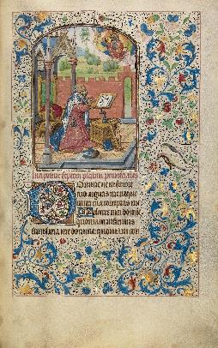
Text: Romans 11:1-2a, 13-14, and 28-32
Title: People who Live by God’s Proclamation

Focus: God calls us to live by his proclamation of
salvation for all people, Jews and
Gentiles, in Jesus Christ.
Function: That the hearers may have courage to
participate in God’s mission.

Structure: Central Image – Multiple Focus

Sermon Study

Introduction:

In American Christianity, Romans 11 has often been torn apart. You can find bits and pieces of it scattered about on the Internet, on various websites speaking about the end times and the restoration of Israel. These verses are joined to prophecies from Daniel, visions from Ezekiel, and images from Revelation. They are joined to doomsday predictions and headlines from newspapers, wars and rumors of wars in the Holy Land. With strong language and even stronger fervor, various Christian organizations fight for the nation of Israel. They claim that once Israel is restored our Lord will return. And usually in the background, scattered among the bible verses and visions, are verses from Paul’s letter to Romans, chapter 11.
How fitting it is, then, that today the lectionary does not read through the entire chapter but rather selects bits and pieces, various verses, and sets them before us! This is how this chapter of Romans is most frequently read – a verse here and a verse there in the midst of arguments about politics and power and the Christian role in ruling the nations of this world . . . all in the name of Christ and for the sake of his return.
Is this what the apostle Paul desired, however? Is this how confused he wanted the church to be? This morning, we will consider Paul’s vision, a vision of God’s greater work for all people, Jews and Gentiles, in Christ, with the goal that this vision will inspire us, as it inspired Paul, to live as one people united in God’s mission.

I. A Confusing Vision:

Have you ever noticed how some art museums post guards near the paintings? If they don’t post a guard, they put a red velvet rope in place to prevent people from coming too close to the paintings. The curators have told patrons, “You can come this close and no closer.” If you reach out your hand to point to a detail, a guard may correct you and ask you step back. Art has a way of drawing us in. We find ourselves moving closer and closer to the painting, examining small details of things that are there.
The only problem with this way of viewing art is that sometimes you can be so close to the painting that you lose sight of what it is really about. We have an old saying that describes this experience – “you can’t see the forest for the trees.” Because a person is so immersed in the trees, they can’t step back and see the forest. Being immersed in the details sometimes prevents you from seeing the larger picture.
Consider a piece of art created by Willem Vrelant, a manuscript illuminator living in the 14th century. At first glance, his work is confusing. It is a picture of King David in an open-air chapel, surrounded by a proliferation of vines and flowers. You know you should look at David but your eyes are drawn to the flowers. Some flowers are deep blue. Others are leaved in brilliant gold. The leaves literally sparkle upon the page. Upon closer glance, you see two birds and, above them, what look like strawberries. There is so much to see that for a moment your eyes get lost in confusion. You are tracing a maze of vines and flowers, catching a bird here and a berry there.
Something like this can happen in reading this chapter of Paul’s letter to the Romans. One is drawn in by the strangeness of Paul’s words. Paul is discussing the status of Israel in God’s plan of salvation. At some points, Paul speaks of the hardening of Israel. He voices claims that God has rejected his people, hardened their hearts. At other points, Paul speaks of the salvation of Israel, their election and being beloved for the sake of their forefathers. When read up close and out of context, his words can become confusing.
They have led some theologians to argue that Paul here lays the foundation for anti-Jewish sentiment in the Christian church. Since God has rejected Israel and chosen the Gentile nations, the church now lives the same way. After the Jews were expelled from Rome, the Gentile church survived and now would have little reason to welcome back their brothers and sisters in the faith. Other theologians have used these verses to argue for a future day when God will restore the Jewish people and to fight for that restoration as a prelude to the return of Christ. This concern for Israel gets expressed in political action and becomes a way in which the church can hasten the return of Christ.

Has God rejected Israel or not? Will God save Israel or not? These are the questions arising from the text. Even more troubling, however, is the picture these verses can give you of God. God seems unfaithful – one time calling a people to be his own and then rejecting them only to call another. What is to keep God from rejecting the Gentile church? Can God be trusted when he makes promises . . . when he claims people . . . any people . . . Gentile or Jew?

II. A Clearer Picture:

Paul is aware of how confusing this is and so he is quite clear about the points that he makes. First, Paul wants all to know that God remains faithful to his promises. God has not rejected Israel, for Paul himself is an Israelite. If God rejected Israel, then Paul would be condemned. Instead, God brought Paul to faith in Jesus Christ and uses him to reach out to the Gentile nations. In doing this, God is remaining faithful to his plan. From one nation, Israel, God promised a Savior for all nations and now, Paul, a Jew, believes in Jesus as this Messiah and reaches out to Gentile nations with this good news from God.
Does this mission to the Gentile nations mean that the church should forget about Israel? By no means. And this is Paul’s second point. The church is part of God’s mission to his chosen people. Paul uses himself again as an example. His ministry to the Gentiles is a ministry that seeks to lead Israel back to God’s grace. And here is where Paul asks us to take a step back from the art piece and to see the larger picture. Paul sees himself and his ministry as part of the larger working of God.
If you stand up close and look at Willem Vrelant’s art work, you will be captivated by vines and flowers. A swirling maze of figures that you struggle to follow. If you step back, however, the picture becomes clearer. When you step back, all of these vines and flowers blend together to form the frame of a picture. A picture of King David at prayer. Below him are the words of Psalm 6. A prayer for mercy. Above Psalm 6, you see what that prayer looks like in real life. David is on his knees. Behind him is a throne. A throne that is empty. On the floor is a harp. A harp that is not being played. David, both king and psalmist, is neither ruling nor singing. Instead, he comes before God in prayer. David knows of his sin and he trusts in God’s mercy as he tries to serve God’s people in this world. If you follow David’s eyes, you will see God, above him, in the air. God’s right hand is raised in blessing. God’s left hand holds the world. In a sense, we see a picture of the mystery of salvation. God who establishes kings and opens the mouths of prophets is the only one who truly rules the world. He has called David to the throne of his people and promised David a descendent who will rule without end. For years, God’s people have held on to that promise. And now, in Christ, Paul sees that promise becoming flesh. God’s promises, heard by Paul in the Old Testament Scriptures, are no longer a confusing maze. Instead, they have become real in the flesh and blood of Jesus.

God promised that he would bring salvation through Israel, through a descendent of David, and that this salvation would reach to the ends of the earth. Though all nations were disobedient to God, God chose one nation, the people of Israel, to be his people and to bring his message of salvation to earth. When some of those people rejected their Messiah, the descendent of David, did God then reject his plan? No. God continued to be merciful. He called forth all nations to believe in Jesus Christ and to receive the forgiveness of sins. Now, faced with Israel’s disobedience, will God forget his mercy? No. Paul lives in hope of an even greater day. A day when his work among the Gentiles might lead Israel, his brothers and sisters in the flesh, into the Church, his brothers and sisters in faith.
Just as the Gentiles were once disobedient and now received mercy, Paul sees a day when the Jews who are now disobedient will be led to repentance and receive God’s mercy. God has consigned all to disobedience, both Gentiles and Jews, that he might have mercy upon all, both Gentiles and Jews. Paul thus lives by hope, by a vision of God’s salvation gathering Jews and Gentiles together in one body, one church, one new Israel, that holds one faith in one God – Jesus Christ who forgives all people of their sins.
As Paul steps back from the details, he is able to see the big picture and it is a vision of mercy on the part of God. As God comes into this world, he finds disobedience among all nations, but God remains faithful to his promises and works mercy, mercy for all peoples, Jews and Gentiles, in Christ. Though the world be disobedient, God will remain merciful. Merciful to all people who believe in Jesus Christ.

III. Living by God’s Promises in Christ:

To live by this vision, however, calls for strength and courage in our world. For several years, in St. Louis, the Roman Catholic archbishop has been participating in a Passover Seder. It is hosted by the Association of Hebrew Catholics, Jews who believe in Jesus as their Messiah and participate in the Roman Catholic church. Each year, Hebrew Catholics and American Catholics gather together around the table and celebrate the Passover, with an eye toward how the promises of this meal were made flesh in Jesus Christ. Every year, however, this meal and table fellowship is greeted with conflict and consternation. Jewish leaders and even some other Christian churches are angered by the event. For them, the Catholic church is overstepping its bounds and seeking to bring about conversion among the Jews.
This is just one example of how God’s people in America are called to live by a completely different story. Our American culture prides itself on freedom of religion. People are able to believe what they want to believe. You’ve seen the bumper stickers that encourage attendance at the church or synagogue or mosque of your choice. You’ve seen the bumper stickers that use various symbols of various faiths to spell out the word, “Coexist.” The larger vision of these bumper stickers is that there are many paths to God and there are many people and we need to respect and appreciate these various ways to God. If all of the religions would just get along, there would be peace in the land. To practice your own faith is one thing and our American culture will support that. But to speak about your faith, as if it might matter to someone else, well that is a different matter. You can worship God and speak to God however you want, believing God to be whatever you want him or her to be. But to speak to others about God or to act as if your God might have a word that is important to others, well that is considered argumentative, disrespectful of others, stirring up conflict, and in some cases even participating in hate speech. So while our culture will protect your right to worship God as you please, it also protects the rights of others and cautions you to be careful about bringing your God to them.
In such a culture, it would be easy to let everyone practice his or her own faith. Your faith is a personal matter, something that is just between “you and Jesus.” The apostle Paul, however, knows differently. To be joined to Christ is to be joined to his mission and God chooses to be at work through his people.
God has a greater story for this world. It is not a story of peace by toleration of various religions. It is story of peace found in the death and resurrection of Jesus Christ for salvation from sin. All have been disobedient. “All have sinned and fall short of the glory of God” (3:23). And yet, God is faithful to his promise to have mercy on all. All “are justified freely by God’s grace through the redemption that is in Jesus Christ” (3:24). When you come near to Jesus, when you are brought to faith by the power of God in his word, you are then sent near to those who are in need of Jesus, Jews and Gentiles, neighbors and family, as God continues to work out his story of bringing salvation to the ends of the earth.

Conclusion:

I’ve mentioned the manuscript illumination of Willem Vrelant. But I don’t think I ever told you the nature of the work. This is part of a Book of Hours, a personal prayer book. It is designed for the individual Christian to guide him or her in prayer. When turning to Psalm 6, the reader suddenly sees, David. King David. Kneeling before God in penitential prayer. Seeing that picture invites one to start praying. It is a personal, intimate way of reflecting on the promises of God. In a sense, this prayer book mirrors the working of God.
God is in mission to save the world and he does so through intimacy. An intimacy made known in the Old Testament through his words of promise. An intimacy made known in the New Testament as the word became flesh and Jesus Christ died and rose for our salvation. And an intimacy made known, even today, through God’s people as they share with others the words that bring faith.
God’s word brings people to life, people like the apostle Paul, and people like you and me. And God’s word then reaches out to others through the lives of his people. Each person becomes one more revelation in the flesh of God’s mission of mercy in this world.
What conversation is God calling you to have with others? What strange and difficult speech is God calling you to say? It may be bold or it may be quiet. It may be large, like a life-long conversation with your father, or it may be small, like a brief conversation with a stranger on the bus. But it is God’s word at work through his people in the world. Paul reveals to us that we are a people who live by a proclamation – the good news of salvation in Jesus Christ. God is here, today, for you. Forgiving you your sin. And God is here, today, for others, seeking to bring them to the faith. He will not stop. He will not remain silent. He will continue to work through his people in intimate ways. He will work through you, through intimate moments with individual people, to fulfill his vision of bringing all nations into one body, the Church, the new Israel, in Christ. Amen.

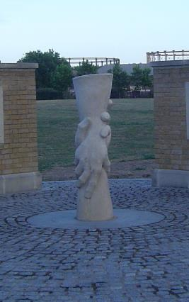
Date: Proper 16 (August 24, 2014)
Text: Romans 11:33-12:8
Title: God’s Greater Plan for You -
Transformed for Service

Focus: God transforms our lives for his
service in the world.

Function: That the hearers may use their
gifts in sacrificial service.

Structure: Image Delayed
Text-Application (closing image)

Sermon Study

Introduction:

The poet, Elizabeth Barret Browning, once wrote:

Earth’s crammed with heaven
and every common bush afire with God
but only he who sees takes off his shoes.

Earth is crammed with heaven. God comes down from heaven and touches the earth, filling it with his glory. But only those who see take off their shoes.
Our readings this morning invite us to be among those who see. They invite us to see the earth crammed with heaven, to see how God in Christ has come down from heaven and touched the earth to fill it with his glory.
Consider the Old Testament reading. Here, we have a vision from Isaiah. Isaiah writes to a future people, suffering in exile away from Jerusalem, and he reveals for them a world crammed full of heaven. “Look,” he cries. And there, he reveals the wonder of God. One family, Abraham and Sarah, touched by God’s grace and the source of God’s blessing for all nations of the world. One sees the glory spread as God multiplies descendents for Abraham, extending his blessing from one family to all nations. Isaiah promises that the wasteland of Jerusalem, the city that is devastated, will experience rebirth and blossom like the Garden of Eden. Songs of sorrow will become shouts of joy. God’s salvation will go forth and, though heaven and earth pass away, God’s righteousness will remain. His salvation will endure forever.
In the Holy Gospel, we find Caesarea Philippi crammed full of heaven. Jesus has drawn his disciples north, far above the Sea of Galilee, where the land breaks forth into hills and waterfalls and fresh flowing mountain springs. The place was ancient. It had been a site for worshipping Baal among the Canaanites, and then Pan among the Greeks, and then Caesar among the Romans. As cultures changed, so did the worship. Yet, here, Peter confesses heaven touching earth in the unchanging work of God, now seen in Jesus. This is not an ancient pagan religion. Peter does not worship a fertility god like Baal or a god of nature like Pan or a god of the political state like Caesar. No, Peter worships God, the creator of all things, who promised to bring salvation to the ends of the earth, and has now come to live and walk among his people. Peter confesses Jesus, a Jew, a Nazarene, to be the Christ, the Son of the living God.
What Isaiah prophesies in the Old Testament reading, what Peter confesses in the Gospel is what the apostle Paul celebrates as he writes to the Christians in Rome. Paul has seen earth crammed with heaven and in these few verses he shares with us a life transforming a vision.
This morning, we will take some time, first to consider Paul’s vision and then to see how it transforms our lives for service in God’s world.

I. Text: Paul reveals God’s greater plan for his people at service in the world.

Consider Paul’s vision.
You know how sometimes when you look at the sun and then look away, your vision is touched by an afterimage of the light? You see the people around you but they look different. They are bathed in the glow of the light. This is what happens to the apostle Paul in our text. He has seen a brilliant vision. The glorious work of God, extending to all nations. And then, when Paul turns and looks at the people of Rome, he sees them in a different way.
Listen to the wonder of Paul at the beginning of our text. Paul is in awe at God’s story of salvation fulfilled in the world. Paul writes, “O the depths of the riches and wisdom and knowledge of God. How unsearchable are his judgments and inscrutable his ways!” (11:33). Paul has seen a vision of the end of the story. The restoration of all peoples in the church. The New Israel of God. That vision is the fulfillment of Isaiah’s prophecy from our Old Testament reading this morning. Isaiah prophesied of a time of “joy and gladness” of “thanksgiving and song.” Isaiah promises that when “the ransomed of the Lord will return and come to Zion . . . everlasting joy shall be upon their heads” and “sorrow and sighing shall flee away” (51:11). This is what happens for the apostle Paul. Paul sees the day of restoration, when God brings about a gathering of nations, all nations, Jew and Gentile, into the church, and Paul’s sorrow turns into singing, his sighing into praise. It is as if Paul has seen the light of a beautiful sunset, a glorious ending to a long and difficult day, and his song changes from sorrow to joy, from sighing to gladness. He offers praise and thanksgiving and glory to God.

Then Paul turns his eyes to the church in Rome. Now, the Roman Christians would not have been glorious to the world around them. Not many of them were rich. Not many of them were powerful. They gathered together in small house churches, their lives a far cry from the glories of Rome much less the glories of heaven. And yet, as Paul looks at these people, he sees earth crammed with heaven and he writes so that they join him in celebrating the wonder of God.
Paul writes, “I appeal to you therefore, brothers, by the mercies of God, to present your bodies as a living sacrifice, holy and acceptable to God, which is your spiritual worship” (12:1). Here, notice how Paul uses the language of sacrifice. The sacrificial worship of God’s people, that glory of the temple in Jerusalem, is suddenly transformed. God’s people become sacrifices, outside the temple, outside Jerusalem, hidden inside the small house churches gathering in the heart of the large empire of Rome. These people are God’s people, transformed into sacrifices, living, holy, acceptable to God. Paul knew that the sacrifice of Jesus Christ put an end to temple sacrifices. His death was the perfect sacrifice. He was the Lamb of God who takes away the sin of the world. By his sacrifice, God’s people were freed from offering sacrifices for sins. By his sacrifice, they were freed to become sacrifices. Living sacrifices of praise. As they poured out their lives in service in the world.
As Paul looks at the people in Rome, he sees an afterimage of God’s glory. They are the body of Christ, at work in the world. Paul begins to see gifts of the Spirit poured out upon the people – prophecy, service, teaching, exhortation, contribution, leadership, and mercy. Not only does God freely forgive all sins but he also freely bestows all gifts, so that people have a purpose and a place in God’s greater story. God has a greater plan for each person in his story of salvation.
This is the vision Paul sees. It stirs his heart with wonder. It opens his mouth with praise. Earth is crammed with heaven as God gathers his people and transforms them for spiritual service in the world.

II. Application: God transforms our humble lives for glorious service.

“Earth’s crammed with heaven,” Elizabeth Barret Browning once said. “But only he who sees takes off his shoes.” And that’s the trouble with God’s people. Often they don’t see this vision of God at work in their lives in the world.
For the apostle Paul, there was some concern that the Roman Christians would take pride in their status and gifts for service. Paul warns them, “For by the grace given to me I say to everyone not to think of himself more highly than he ought” (12:3). God’s people, today, however, often have the opposite problem. Ask a fellow Christian how God works among his people, and see what they say. Often we will point to the service of others rather than confess God’s work through our lives. Often we will point to moments set apart for worship, rather than confess God’s work in daily life.
For example, some will point to the pastor of the congregation. He is God’s servant, the one the Holy Spirit has called through God’s people to serve in their midst. They are right. But God’s work is not limited to him. Give it some more thought and you may name a few other members. Old members. Faithful members. Those who have gone before us. And soon our mind drifts from the present to the past and then we begin to speak of how God worked among his people. Great figures of the faith come to mind. We talk about what God did through his servant Martin Luther. The rich music of Bach. The inspiring hymnody of Gerhardt. We see and celebrate God’s gifts to the church, how God calls, gathers, enlightens, and equips members for service in a particular time and place. But turn from the past to the present, and the vision changes. The glory fades until we only see a very small group of very few people that we speak of as serving God. Our vision is nowhere near the inclusive all-embracing celebration of Paul.
Listen, today, to the apostle Paul. He invites you . . . today . . . to trust in God’s promises and experience his greater plan for you.
God has brought about your salvation in Jesus Christ. He has offered the perfect sacrifice that takes away your sin, that forgives your blindness and opens your eyes to see and your lives to celebrate the working of God. God does more than work in the lives of others. He works in your life . . . for others . . . in this world. This is why Paul starts to name gifts – actions such as teaching, service, leadership, mercy. His list is not complete. It is only suggestive. But Paul names these things so that you can see how God is at work in your life. Paul invites you today to be transformed by the renewal of your mind. He encourages you to test and discern God’s good and gracious will in your life.
You may devote your life to caring for cattle or tending the earth that it brings forth food for the table. This stewardship of creation is a gift from God. Not all people are called to such service but God in Christ has called you and equipped you for this work. You may teach the faith to your children. Not in formal classes with desks and lectures and quizzes but informally, in the car as you drive your son to soccer practice and talk about challenges to his faith, or at the nursing home, as your children visit their grandfather and you offer to pray. Parenting is a gift from God. Not all people are called to such service but God, in Christ, has called you and equipped you for this work.
Martin Luther taught us to see the marvelous expanse of the mercies of God, working through us in our vocations. To live in God’s mercy is to enter the world and discover God at work in our humble lives. He transforms us for service.

Conclusion:

There is a monument east of London at Three Mills Green. It pictures two hands, joined together, in self-sacrificial service.
Over a hundred years ago, Thomas Pickett was working in a well. He was overcome by the carbonic acid (the “foul air”) that gathered in the well. Godfrey Nicholson responded. He went and reached out his hand to help. He was followed by Frederick Eliot and then Robert Underhill. Each worker, in succession, offering a saving hand in rescue. Each worker dying in the end. To remember these men and their self-sacrificial service, a workers’ memorial was erected. Two hands, joined together, in self-sacrificial service.

If you were to go to London, it would be easy to miss this monument. After all, London is filled with so many glorious things to see. The crown jewels. Big Ben. Buckingham Palace. The changing of the guard. But there, in east London, at Three Mills Green, stands a much humbler sight. A memory of people, ordinary people, who offered their lives in acts of self-sacrificial love. Their daily vocation became a place for service, service to others and service to God. This place does not gather many crowds and it does not inspire tours but it does recall the way God works in the world. Through the lives of his people in their daily vocations. This is how God’s hand reaches into our world. He touches his people, transforming them for service, so that they offer their gifts as a sacrifice of praise.
What this monument does in East London, Paul does with his words in this letter. He calls us to see the glory of God, hidden in the lives of his people, in self-sacrificial service on earth. Our world would have us conform to its ways. Seek glory and power by gaining things for ourselves. In the ways of our world, religion can become one more tool we use to make ourselves better. Claiming the power of God to gain glory on earth. God’s ways are different, however. Humble. Hidden. Sacrificial. Selfless. In a world attracted to glory, the apostle Paul asks you to see God’s greater plan for you. You have been joined to the body of Christ. Made part of his people by the forgiveness of your sins. And Paul now invites you, in view of God’s mercies, to no longer be conformed to this world but to be transformed for service. To live by giving rather than gaining. By service rather than selfishness.
In this way, the church is the afterimage of the glory of Christ. It reveals the ways of God in the world. We are the body of Christ, drawn into his public ministry. Our lives are monuments of his self-sacrificial love. Each life touched by the hand of God. Your life joined to the ministry of Christ. “A living sacrifice, holy, and acceptable to God.” Amen.

Date: Proper 17 (August 31, 2014)
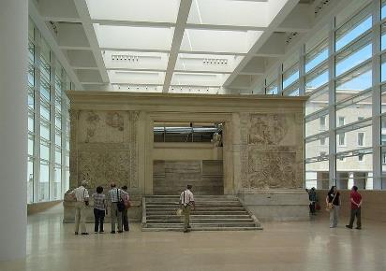
Text: Romans 12:9-21
Title: God’s Greater Plan for You -
Living in Love

Focus: God invites others into his
community of peace
through lives of self-
sacrificial love.
Function: that the hearers may love
one another in the
kingdom of God.

Structure: Central Image -Single Focus

Sermon Study

Introduction:

Our text from Romans this morning is challenging. Paul writes to encourage God’s people but his words are overwhelming to us. “Let love be genuine. Abhor what is evil. Hold fast to what is good. Love one another . . . be fervent in spirit . . . rejoice in hope, be patient in tribulation, be constant in prayer” and that’s only a small portion of the first three verses. His list goes on and on.
Listening to his words it’s easy to feel exhausted. To feel unworthy. To wonder if the Holy Spirit could ever form within us all of these desires of God. Paul’s list is overwhelming and leaves us wondering, “Where do we start? What should we pay attention to? What is a Christian to do with all of these words?”
Let’s say you were to take one exhortation a day and really work on that one. So, for Monday, you take “Let love be genuine” and all day, you try to demonstrate genuine love. Passing by someone in the hall at work, you say, “how are you doing?” only this time you stop to listen and then you respond to what’s going on in her life. Today, love is more than the words of a casual greeting. It involves action and interaction, genuinely experienced and genuinely expressed. Tuesday you move to the next exhortation and work on “Abhor what is evil.” If you were to do this for every one of these exhortations, it would take you almost a month to get through the list. And that would be spending only one day on each one and assuming that you could actually do these things. Paul’s list of exhortations is overwhelming to the Christian.
Yet maybe Paul was trying to overwhelm God’s people – not with commands about what they had to be doing, but with a glimpse, just a glimpse of the kingdom of God, coming alive in their midst.
In our text this morning, Paul is not setting out a twelve-step program to “build the better spiritual you” but rather revealing the varied ways in which God is at work in the world. And Paul invites us to consider that vision this morning so that today, in our small corner of this vast world, we too can participate in this ever-living kingdom of God.

I. God’s Kingdom Comes Not with Brutal Force but in Self-Sacrificial Action:

The city of Rome was overwhelming. Think of what it was like for the early Christians in Rome. Rome was considered the center of the world. Its public spaces were filled with monuments, arches, forums, and images honoring military victories and the imperial family. There were temples for worshipping not only gods and goddesses but even past leaders who were now proclaimed gods.
Consider the Altar of Peace. It was a monument built on the Field of Mars. This space was once used for military training but now, at the time of Paul’s letter, it was the site of much building activity. This monument to peace was built and dedicated about 13 years before Jesus was born and, in just a few years, Nero would have an image of it stamped on a coin. It was a monument that captured the glory of Rome and the imagination of her people. It invited Roman citizens and foreign dignitaries to participate in a much larger story. The story of power and glory leading to peace in the Roman world.
Surrounding the altar were walls of marble, beautifully decorated, each side measuring about the length of a large mobile home. At the top of these walls were figures, human figures carved into the marble. These figures were not small. They were life size, towering over you, as you looked up from the ground. They were also very realistic. People you could identify, people within living memory. On one side was a panel of Roman senators and priests. On another side was Caesar Augustus, leading his servants and family in procession up to the altar. Through his military victories, he had established Roman peace and now invited all people, those in the past and those in the present, to live in the glory of Rome. The Altar of Peace invited Romans to live in the world of imperial power. They were to trust in Rome’s military might and service to the gods for the establishment of peace. If you looked closely, within the panel, there were even small children, from different nations, suggesting that all nations would come to worship at this altar and live within the power and the peace of Rome.
Now imagine being a Christian, living in Rome, surrounded by such images of power. It would have been easy for the early Christians to question the power of God. They were gathering in small house churches. They didn’t have political or military strength. They didn’t have a system of colleges and seminaries for training pastors. They didn’t have libraries of theological texts defining the Christian faith. They didn’t even have what we know as the New Testament. They had the Old Testament Scriptures and the proclamation of the apostles, including this letter from Paul. Surrounded by images and temples of the imperial cult, the Roman Christians may have wondered about the kingdom of God. How could the kingdom of God come in a place like Rome? And when would they know that they were experiencing it?
For these Christians, the apostle Paul paints an overwhelming picture. He gives them a glimpse into the ways of God. Paul would agree that there was a war going on, a conflict that threatened the lives of God’s people. His listing includes the figures of war. He speaks of enemies of God’s people, tribulation, persecution, and evil that needs to be abhorred. Yet, surprisingly, Paul does not call for aggressive military action. He does not celebrate massive military victories with this listing. Instead, he calls the people to service. Paul writes, “do not be overcome by evil, but overcome evil with good.” Overcome evil with good.
Paul knows that the hope of the Christian lies not in the figure of Caesar Augustus but in the figure of Jesus Christ, our Lord. The one who overcame evil with good. The work of Christ for our salvation was not a triumphal march toward victory through the streets of Rome but a journey of self-sacrifice ending in Jerusalem. In our gospel reading this morning, Jesus speaks of his passion. Here, he gives us the story of God that saves the world.
I don’t know if you have ever seen Mel Gibson’s movie The Passion of the Christ. That movie is extremely violent and graphic in its depiction of the passion. It reveals that the power of Rome was a force to be reckoned with. Behind the marble friezes and the beautiful monuments to peace was a brutal power and system of punishment that stripped all enemies of human dignity and ruled by force. Hidden within that brutality, however, was the self-sacrificial work of God. And it is that one small story, not walking in triumphal procession through Rome, but making its way through the streets of Jerusalem, that is our source of peace and hope.
Gibson’s movie has one scene that captures this vision of God and the sacrifice of Jesus that brings peace. It isn’t in Scripture, so Gibson has taken some poetic license, but it does reflect Scripture and what God is teaching us by faith to see. It’s that moment when Jesus speaks to his mother Mary on the way to the crucifixion. Jesus is bloodied and beaten. He is carrying his cross through the crowded streets of Jerusalem. He falls for the third time and Mary, his mother, reaches out as if to catch him. Her mind is filled with images of the past. She remembers him running to her in the streets of Nazareth. These images of the past only make the present more painful. She realizes that this time she cannot catch him, she cannot save him. This day her Son is going to die.
But when Mary reaches out to Jesus, Jesus stops and reaches out to catch her with a word. We have a moment where we see Jesus. His face bruised and bloodied. In the background is the cross. But his eyes are gazing at us with wonder. He turns to his mother Mary and he says, “Behold I make all things new” (Isaiah 43:19 and Rev. 21:5). When Mary’s mind is filled with images of the past, Jesus offers her a promise of the future. When Mary’s heart is breaking over the end, Jesus comforts her with the new beginning. When Mary sees death, Jesus reveals to her life. Jesus teaches Mary to see this horrible destruction as God’s most creative act.
God is in control and at work for the world in the self-sacrifice of Jesus. While Rome flexes its military muscle and the religious leaders implement their deceptive strategies and God’s people give in to despair and give up their hope, God is in control, at work for his world. Jesus walks through the streets of Jerusalem to offer his life as the one true sacrifice that forgives all sins for all people for all time. In Jesus is our source of peace with God and hope for the world. This is the peace that Paul knows and proclaims to the Roman Christians and to you today. But this peace isn’t something that we only look back at, remembering an event in the annals of history. No, Paul invites the Roman Christians and you today to live in this peace now, as you experience the kingdom of God.

II. God’s Kingdom Comes Not with Massive Military Victory but in Small Seemingly Insignificant Actions:

What does such life look like?
In our gospel reading, Jesus turns to his disciples and asks that they follow him. “If anyone would come after me, let him deny himself and take up his cross and follow me. For whoever would save his life will lose it, but whoever loses his life for my sake will find it.” We know these words. We’ve heard them before. Some of us have committed them to memory. Many of us have sung them in hymns. But what does it look like to live them? What does it mean to take up your cross and follow Jesus?
This is what Paul gives us a glimpse of in his letter today. Notice the type of things that Paul celebrates in his listing. For Rome, it took massive military campaigns to lead to the erection of this monument. Rome had begun its conquest of the Iberian Peninsula in 218 BC. It took 200 years of fighting and infiltration until they could finally declare victory under Augustus (e.g., the Cantabrian Wars) and celebrate that victory in this massive altar to peace. This listing Paul offers contains no massive military victories. Instead, it celebrates the small, seemingly inconsequential ways of God. Acts of brotherly affection. Caring for the needs of the saints. Taking notice of the lowly. And even loving one’s enemies. Offering a cup of water or a gift of food to an enemy who is thirsty and hungering. These are the ways of the kingdom of God.
The Romans carved figures of leadership into marble and made them into gods as a way of celebrating peace. God forms his kingdom not with stones but with flesh and blood. He takes you as his people, washes you in the waters of baptism, fills you with his Spirit and brings you to life. His work may not be noticed by the world. It may not be celebrated as a major turning point in history. No, it may simply be a moment when you rejoice with someone who rejoices or weep with someone who weeps. But this is a working of God. A real life tangible expression of God’s Spirit, at work in our world, bringing about a different kind of peace.
When encountered as a listing, a series of exhortations that come over us all at once, these words can be confusing and challenging. We don’t know where to start. But when encountered as a community, a way in which God’s Spirit works through flesh and blood in this world, these words are comforting and encouraging. They open our eyes to see the ways in which God is near us, very near us in daily life. Once you hear these words from Paul, you begin to see God at work among his people all the time. And the vision, no matter how small, no matter how insignificant, can bring you an eternal joy. Consider the pastor who went to the hospital to visit a parishioner. She was in the last stages of cancer, heavily medicated, unresponsive, but he went to weep with those who weep. When he rounded the corner he was surprised by what he saw. Her daughter was there at the foot of the bed. She had taken the sheets and thrown them back and was putting lotion on her mother’s body, starting at the feet. This was some expensive lotion. More than the daughter could afford. As he walked into the room, the room smelled beautiful. The daughter gave him a mischievous smile and made him promise not to tell her children. Her kids had given her this lotion for Mother’s Day. “Because you never do anything for yourself,” they said. And here she was, putting that lotion on her mother’s feet. Her mother was unresponsive. She wouldn’t know the difference. But the pastor did. That day, he saw a vision of the kingdom of God. Not carved in marble but formed in flesh and blood. Immersed in suffering. Yet alive in love. Mother and daughter. Giving mercy. Receiving mercy. Surrounded by death and dying, yet living in an act of selfless love.

Conclusion:

This is the vision Paul invites us to see this morning.
You can go see the Altar of Peace if you want. You will need to catch a flight to Rome and go to a museum. Once there, you can stand in the stillness and coldness of that room and look at this monument, this celebration of the power and the glory of Rome. At the time, it challenged the Roman Christians. It offered a vision of peace and glory in the power of Rome. Now, the monument is a relic. A museum piece. An object of art. The victories it celebrated, the empire it served, the peace it promised, these are all gone.
But the vision of God that Paul wrote about in this letter. The kingdom of God that came in Jesus. The peace of God that his Spirit works among his people. These remain. Paul wants you to see God alive and at work today in your midst. To do that, Paul doesn’t need to take you to a museum. No, he invites you to look around you at the people God has gathered in this place. Your brothers and sisters in Christ. Here, God is at work in love. He has called you in Christ to be his people. He has forgiven you and made you his own. And now he works in you and through you by the power of his Holy Spirit. You can see God at work. Not in great stories of massive military victories but in small stories of self-sacrifice and everyday acts of love. In these ways and with these people, God continues to work in human history, leading us all in holy procession to that day when he will return and bring to earth his heavenly kingdom that shall have no end. Amen.

Date: Proper 18 (September 7, 2014)
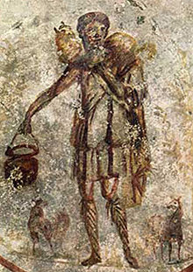
Text: Romans 13:1-10
Title: Living in Mercy and Faithful Obedience

Focus: In Christ, God rules over us in mercy and,
by establishing civil authorities,
God rules over all.
Function: That the hearers may trust in God’s
mercy and live in faithful obedience
to God’s rule through civil authorities.

Structure: Multiple Image

Sermon Study

Introduction:

“All roads lead to Rome.” I’m sure you’ve heard this common saying. It comes from a French fable by Jean de la Fontaine. What this writer once observed in seventeenth century France is what early Christians experienced in first century Rome. “All roads lead to Rome.”
Rome was the center of a massive set of roadways. Marked with milestones, these roads spread outward from a single monument erected by Augustus: the golden milestone, placed by the temple of Saturn. On that monument, Augustus had listed the major cities of the empire and the distances to them. So, standing in Rome, before that monument, one could see the extent of the Roman Empire. Roman roads stretched outward. They went up to the Wall of Britain. They ran “alongside the Rhine, the Danube, and the Euphrates.” And these roads spoke of more than travel. They spoke of power. The power of the empire. Roman officials could be sent to any district in that system and military traffic, camping along these roads, only reinforced this sense of power. Standing on a Roman road, one knew the Roman Empire’s extent and its vast military might.
So, he stands there, along the Appian Way, looking off into the distance. There is nothing about his features that would cause you to notice him. He looks like any other young Roman man. Clean-shaven, wearing a toga, carrying a bucket of water, and holding a lamb around his neck. Yet, standing along the Appian Way, this man draws our attention not to the ways of Rome and its military power but to the ways of God, his mercy and power.
This one figure is the monument, if you will, raised up by God for all peoples. Through him, one receives God’s mercy and, in him, one responds to the powers of this world. As we consider Paul’s letter to the Romans this morning, we will look at it through the eyes of this figure, seeing God’s action of mercy in Jesus and considering how he teaches us to respond to the powers of this world.

I. God’s Mercy in Jesus:

This figure of a young Roman shepherd is one of the earliest pieces of Christian art. It stands along the Appian Way. But not above ground. No, this figure is under ground, a fresco painted on the walls of the catacombs of St. Callixtus, a complex of tombs that reaches downward four levels and outward 12 miles. When above ground, this figure would call to mind the life of Rome. But, when under ground, where the earliest Christians buried their dead, he offers us a different vision.
This figure was painted years after Paul wrote his letter to the Christians in Rome. And things had gotten worse, not better. The military power of Rome had turned against Christians. They were killed in persecution, slaughtered in sport. Somehow, however, as some things in Rome became darker for the Christians, other things became clearer. These early Christians, suffering persecution, began painting figures on the walls of their graves. Clear visions of God’s mercy and power. In the darkness of the catacombs, they painted with the light of salvation.
Here, in the tombs, the early Christians buried their martyrs, killed and cast off by the powers of the world. On the walls of these tombs, the early Christians painted their Savior, confessing the wonderful power of God. A power that saw and claimed the persecuted, the killed, the powerless, and the rejected. This one Roman figure, with a lamb across his shoulders, is the great Shepherd of the sheep. This is how the early Roman Christians retold the parable of our gospel lesson this morning.
Jesus sees their suffering and he comes here to find them, to bind up their wounds, and gather them together and give them the promise of life everlasting. Taking them upon his shoulders, he will raise them up and bring them to a new creation and joy that never ends. Here, in these mazes of death, the early Christians confessed Jesus to be the way, the truth, and the life. He is the one who has come to save God’s people and he calls all people to follow him.
When you look closely at this fresco, you notice something interesting. It does not attempt to offer a realistic picture of Jesus. You can’t recognize Jesus in this figure. He is not a bearded Palestinian. He has no halo around his head. No wounds in his hands or side. No, in this picture, he’s a Roman. A young man, clean-shaven, wearing a toga, carrying a lamb upon his shoulders. What the earliest Christians understood was that the way you recognize Jesus is not by what he looks like but by what he does. He claims his people in everlasting love and has promised to return and bring his people into a new creation. In the light of this world, Jesus may not look like a ruler but, in the darkness of death, he reveals his power, his promise of life everlasting and of a world without end. The same is true today.
Look around you today. Crowds are not following Jesus, rulers are not bending their knees before him. Yet he remains the Savior of the world. Though our world reject him as the promised Messiah, though religious scholars question his sayings and the accounts of his resurrection, though academics claim that his followers are blind, foolish, even stupid, still this Jesus comes for you. Through his death and resurrection, he opens the way of eternal life. He brings you into his kingdom. Buried with him in baptism, he raises you to new life, and, until that day when he returns, he will lead you like a shepherd through the pathways of this world. Yet how do you walk in the way of this kingdom? Particularly, how do you relate to the civil powers of this world?

II. God’s Rule through Civil Authorities:

Consider what happened when these early Christians left the darkness of the catacombs and went out into the world. Imagine how difficult it must have been to believe in Jesus and yet live in Rome. You come out of the catacombs and into the light. For miles and miles, you are surrounded by the roads of the Roman Empire. You live in the midst of its power and might. How do you live in this empire as a Christian? How could you live in one world knowing that you were a citizen of another? That is the question Paul attempts to answer in our text for today. He reveals God’s greater plan for you as you not only live by his mercy but also honor his power.
Paul learned this way from Jesus, in a blinding vision, on a Damascus Road. And now, in this letter, Paul shares this wisdom, to the earliest Christians in the heart of the empire. Paul offers words that reveal how God rules over all things. Whether you are walking along the roads of Rome or the streets of [name of area familiar to congregation], you live as a child of God. You respect God’s authority, his power to rule over the world. And you rejoice in his mercy, as you share his acts of love with his world.
Paul encourages the Roman Christians to see God’s authority behind the power of the Rome. They were to respect Roman rulers not because they were powerful but because, in some strange way, they were servants of God.
At the time Paul wrote this letter, Nero publicized his rule as the dawn of a golden age. Yet, privately, there were rumors that his mother had poisoned Claudius, her husband and uncle, to secure the throne for her son. Nero himself joked about the poisoning, saying that Claudius became a god by eating a mushroom. A poisoned one. Why use a sword when a mushroom can work just as well? While there were suspicions of assassination and conspiracy and a fearful use of power, Nero pictured himself early on as one who promoted peace. When Seneca offered an essay to Nero on mercy, he celebrated the fact that Nero had sheathed the sword. Prophecies said that his reign was the dawn of the golden age. In one poem, a child comes in from working in the fields and stands before a sword hanging in his father’s house and marvels at it. He does not need to carry a sword nor use one since this is a time of peace. What the public heard about Nero is that he had hidden his sword but privately what they whispered about Nero revealed their darkest fears.
Imagine the difficulty this posed for Christians. How do you relate to the civil authorities when publicly they say one thing and privately do another? How do you obey, as a Christian, when it seems like the rulers you are asked to obey are obscured by propaganda so you never know the truth? The question is as relevant for Christians today as it was for Christians in Rome.
Look at our political landscape and the struggles of Christians. Some refuse to have anything to do with politics. “They’re all a bunch of crooks,” some Christians say. They withdraw from the political world, from the responsibilities that they have as citizens, because politics are corrupt and they don’t want anything to do with that world. Others want to use the political realm to create a Christian nation. Turning away from God’s gift of the church, where God gathers his people through the proclamation of the gospel, they turn to the nation, wanting the nation to take the place of the church, proclaiming the gospel from political offices and enforcing God’s word through the power of the sword.
The apostle Paul, however, offers another way. Paul knows of two kingdoms, two ways in which God is at work in the world. Earlier in the letter, Paul has recognized God’s gift of the church. The church is the means whereby God proclaims salvation, gathering for himself a people who share his message of salvation with the world. Now, Paul speaks of God’s gift of civil authority. One looks to such authorities not for a proclamation of the gospel but for an enactment of God’s good rule in the world.
Paul could have spoken like any other propagandist. He could have argued for obedience to rulers because of their character, because they showed mercy, or because they had sheathed the sword. But Paul anchors Christian obedience not on something as temporary and fleeting as the person in office or the laws of the empire. No, Paul anchors obedience on something as powerful and eternal as God. “Let every person be subject to the governing authorities. For there is no authority except from God, and those that exist have been instituted by God” (v. 1). Paul turns the eyes of the early Christians from the realm of Rome to the realm of God. They are to see that the present authorities are masks of God, offices that God has established in his rule of the world. Though Nero’s propaganda encouraged people to think he had sheathed his sword, Paul claims that God has given one to him and that he does not bear it in vain (v. 4). Whether he believes or does not believe, he is a “servant of God” (v. 4), placed in authority.
Some who hold these offices test God’s people, driving them deeper and deeper into the experience of faith, so that Christians believe in the midst of persecution and confess the faith in the midst of a world of contempt. Others offer a public witness, honoring God by their words and seeking to serve him as best they can through their actions. Our relationship to these authorities, however, is not based on their person but on God’s work. Within their offices, we see the power of God, establishing order for all people in the world. They have been given the power to restrain evil and promote good. Sometimes they use it wisely. Other times not. But that does not diminish their office, the fact that God has established the civil authorities not to save people but to care for them.

Conclusion:

Paul’s words encourage Christians to see how God can work through civil authorities, rewarding good, restraining evil, forming a society of peace where his people can gather and the word can be proclaimed. Honor is not given blindly. Respect is not paid indiscriminately. Christians follow rulers not on the basis of political propaganda or dreams of establishing an earthly kingdom for God.
No, we recognize that God has established his kingdom in Jesus Christ. Through the gospel, God has called you into that kingdom and, though this world and Satan himself should fight against it, that kingdom will never be taken away. When you walk through the valley of the shadow of death, this Jesus is with you. Like that early Christian fresco of Jesus the Good Shepherd. Through him, you live. In him, you die. And, by him, you will be raised to eternal life.
As you walk through the streets of this world, however, we are also aware of another working of God. God has established offices and uses them to create civil order and foster the public good. Power is recognized. Obedience is given. Not blindly. Not stupidly. But faithfully, as we seek to do good, to avoid evil, and to honor these rulers as “ministers of God” (v. 6).
The God who rules his church in mercy also rules over all. Therefore, as Christians, we trust in God’s mercy for our salvation and we live in faithful obedience to civil authorities, knowing that they have been instituted by God. Amen.

Date: Proper 19 (September 14, 2014)
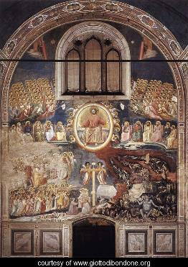
Text: Romans 14:1-12
Title: Living in Light of Christ’s Eternal Rule

Focus: God has woven his loving rule in the
details of our daily lives.

Function: that the hearers may live peaceably
as heirs of God’s eternal kingdom.

Structure: Central Image – Multiple Focus

Sermon Study

Introduction:

This morning, Paul’s words to us are strange. Strange, in that he joins two very different things together. In just a few short verses, Paul moves from talking about food to talking about the return of Christ.
Paul begins by talking about eating. Not eating as in partaking of the Lord’s Supper but eating as in consuming daily food. Some Christians in Rome are eating only vegetables and others are eating all things, without any discrimination. This matter is so small and so specific that scholars today have trouble understanding it. It seems there was an argument about whether or not Roman Christians should keep Jewish food laws. Could they eat meat that was not kosher? If in doubt, should they abstain from meat all together? So, on the one hand, Paul is writing about something small and temporal. He is delving into the details of our daily dishes.
But then, in just a few verses, Paul speaks about that which is large and eternal. He asks us to remember that we all shall stand before the judgment seat of Christ. We will give an account to him of our lives. Here, Paul’s vision expands. He sees the return of Christ and the Last Judgment. This judgment embraces life, all of life, both now and forever.
In just a few short verses, Paul moves from the food on your plate to the judgment seat of Christ. From the small and the temporal to the large and the eternal. This raises a question. What does eating have to do with the judgment seat of Christ? How are these two joined together?
For Paul, the return of Christ is not something distant from God’s people. This rule of Christ is woven into the details of our daily lives.
I. First Focus: God has woven our daily lives into his loving rule.

In 1306, an artist once depicted this reality. In Padua, Italy, Giotto Di Bondone painted the walls of a church. The church is called the Arena Chapel, because it was built on land that stood next to a Roman arena. When you enter the chapel, you are surrounded by frescoes that tell the story of God. The life of Christ and the life of Mary are painted on the walls. Three levels of paintings. While the frescoes are beautiful, what I want you to consider is what happens when you turn around to leave the chapel.
In some of our congregations, as you leave church, you will find a small sign posted by the door. “You are entering the mission field,” it says. The letters are small and only those who are literate can figure out what it means. In this chapel, however, the entire back wall is covered with a fresco. A picture of the return of Christ. There is Christ, seated in the center, the largest of all the figures, surrounded by a halo of light. His left hand grasps at the edge of the halo as if he is about to enter into your world. He is returning in judgment. Dividing the sheep and the goats. As you walk out of this chapel, the artist reminds you that the world you live in is not your own. You are part of God’s kingdom and Christ is returning in glory to judge the living and the dead. Whatever your plans for the day, the artist wants you to see them through the eyes of Jesus. Your daily life is woven into his kingdom and everything you do, eating or sleeping, working or playing, is ruled by God.
As Paul writes, “For none of us lives to himself, and none of us dies to himself. For if we live, we live to the Lord, and if we die, we died to the Lord. So then, whether we live or whether we die, we are the Lord’s” (Rom. 14:7-8). In baptism, God has claimed you as his own. He has joined you to Christ. This Christ has risen and ascended and promises to come again. Until that day when he returns, you are his. Your daily life has been woven into his kingdom and his loving rule is expressed in the details of your daily life. Paul, like this artist, wants Christians to know that God has woven his loving rule in the details of our daily lives.

II. Second Focus: We can forget about the loving rule of God.

Unfortunately, this is a truth that we sometimes forget. In the corner of the painting there is a terrifying vision of hell. Demons are torturing humans and you can see the figure of death, seated, devouring everyone he can get his hands on. Even more terrifying, however, is one small figure. A lone man, journeying, with a bag on his back. He is not terrified. He is just walking . . . toward death. He is taking his time and yet he is being led by demons to the pits of hell. There is always the danger that we will forget that we live in God’s kingdom and end up on the road that leads to destruction.
In our gospel reading this morning, Jesus gives us a picture of this problem. It is hidden in the background of a parable that he tells. In his parable, Jesus contrasts two kingdoms: the kingdom of God and the kingdom of this world. In the kingdom of God, all debts are forgiven. In the kingdom of this world, all debts must be paid by the one who owes them. A servant is brought before his master with fear and trembling. He comes with fear and trembling because he lives in the kingdom of this world. All debts must be paid by the one who owes them and he has a debt to his master. A huge debt. If a talent was worth about 20 years of labor, ten thousand talents was worth 200,000 years of daily labor. This debt was one he could never repay. He comes before his master in fear because he lives in a kingdom where debts must be paid and there is no way he could ever pay this debt. His wife and his children could be sold into slavery, his property dissolved, his life ruined and he still would owe a debt to the master.
The master, however, lives in a different kingdom. A kingdom where debts are forgiven. And so, out of mercy on his part, he forgives this man his debt. That moment of forgiveness is not just a transaction. It is an invitation. An invitation by the master to live in a new kingdom. The master invites his servant to live in a world where debts are forgiven. When the servant leaves, however, he forgets that he lives in this new kingdom. Coming across someone who owes him a little, he demands it all. And without knowing it, this servant has walked into prison himself, choosing to live in a kingdom where everyone pays his or her debt and he too, now, must suffer in prison until his debt is paid. Forgiven by God and invited to live in a kingdom where debts are forgiven, this man chooses to live in a world of judgment where everyone has to pay their own debt.
With this parable, Jesus is inviting his disciples to live in God’s kingdom, a kingdom where their debts are forgiven, their sins are paid for not by their own hard work and effort but by the death and resurrection of Jesus Christ. In Jesus, God has opened the door for all of us to live in this kingdom, this kingdom where sin is forgiven in Jesus Christ. Yet, like the foolish servant, we sometimes choose to live in a kingdom where people have to pay their own debts.
That’s the problem concerning Paul. God’s people in Rome have all been forgiven in Christ. God has brought them to new life and they live in Christ’s eternal kingdom. But, for them, Christ’s kingdom doesn’t change how they live with one another. Right now, they are fighting over food. Those who are strong in faith are despising those who are weak and those who are weak are passing judgment on those who are strong. God’s church is being divided, broken apart, filled with despising and judgment rather than forgiveness, forbearance, and love. God has saved them all in his act of dying love and yet that love is dying. They no longer see it, nor live it, but despise and judge one another over something as small as food.
Unfortunately, such fighting didn’t end with the first century. It continues even today. The church has long remembered the death of its saints. Many of them were martyred. Killed by the world as they witnessed to the faith. In their death, we see the dying love of Christ. Sometimes, on their shields, you will find the instrument of their death. So, for St. Peter, you have a cross, turned upside down. For James the Less, you have a saw. Tradition has it that at 96 he was pushed off the roof of the Temple in Jerusalem and when he continued to live, he was clubbed to death and his body sawn in pieces. The church remembers these saints and the instrument of their death as they died in conflict with the world.
Yet not all Christians are martyred outside the church. We have those who have been martyred in the church as well. They’re there, you know. These martyrs of the faith, martyred in their own congregations. They’re there because we have a way of killing our own. We don’t make shields to remember them. Rather they tend to be buried in the records. People who were once quite active in the church but now mysteriously have stopped coming, and even more mysteriously no one asks why. Were you to ask them, I am sure they could tell you. They have stories of battles they fought within specific congregations. Over their heads, we could place instruments of their death, like hymnbooks they fought over, additions they said should never be built. Even something as small as a church recipe that never made it into the congregational cookbook. Yes, the things over which we fight can be small, almost inconsequential, like eating vegetables or meat, but the damage that is done, the division of Christ’s body, the way in which God’s people turn away from his rule of love, is huge and can lead into people turning away from God and being lost for eternity.
This is what Paul was concerned about in Rome. And this is a concern that still confronts the church today. How do we live with one another? Do we receive one another as people for whom Christ died? Do we live in the love of God that has brought us into his kingdom and will lead us all to eternal life with him?

II. Third Focus: God forgives us in Christ and invites us to love one another
in him.

Today, we can be thankful for God himself comes among us and forgives us our sins in Jesus Christ. As the apostle Paul writes, “For to this end Christ died and lived again, that he might be Lord both of the dead and of the living” (Romans 14:9).
When Christ Jesus entered this world, he came in humility. He gathered about himself those who had accumulated great debts. Tax gatherers who were stealing from God’s people, women who had taken their bodies and sold them. Those who had wandered far from God’s ways and were living in a distant country, in debt, and unable to set themselves free. These are the ones that Jesus gathered around him and these are the ones for whom Jesus died. Although he had no debt of his own, Jesus used his priceless life as payment for sin. Not his sin, but ours. Our lack of love for one another. Our willingness to judge and despise those for whom Christ died rather than forgive and forbear. These sins . . . all sins were laid upon Jesus and he died in payment of their costly debt. Today, Paul proclaims this wonderful truth among us. Jesus Christ died and lives again for you. That you might be his own and live under him in his kingdom. That he might be Lord of the living and the dead. We who have been baptized into Jesus have been baptized into his death and now our lives are his and his kingdom is ours. His kingdom is eternal, established in the heavens, and no one on this earth can ever take it away.
This is the kingdom that Jesus describes in a parable this morning. This is the kingdom that Joseph, by faith, lives in. When Joseph’s brothers came before him, they knew that they had sinned against him. They had sold him into slavery. They lied to their father, acting as if Joseph were dead. And now, after their father is dead, they lie to Joseph, telling him something their father never said, hoping to save their lives by a lie. There they are, on their knees before Joseph, hoping to live by a lie they put on the lips of their dead father. Yet Joseph knows of their sin, their deception, and their lies. And not only is Joseph wise, he is also strong. He rules over the people of Egypt, second in authority only to Pharaoh himself. Joseph could have them sold into slavery. He could banish them from his sight. He could rule over them in vengeance, yet Joseph chooses to rule over them in love. They try to live by a lie they put on the lips of their father but Joseph invites them to live by the truth that comes from their God. Joseph lives by love not hatred. By doing that, he invites them into a different kingdom, a kingdom greater than Egypt. A kingdom ruled over by someone greater than Pharaoh. Joseph invites his brothers to live with him in the kingdom of God. Here, God is alive and sins are forgiven and God’s people live with one another in love. “Do not fear,” he says, “I will provide for you and your little ones” (Genesis 50:21).
Jesus foretells this kingdom in a parable to his disciples. Joseph foreshadows this kingdom in love to his brothers. Paul now proclaims this kingdom in Christ for all people. In the death and resurrection of Jesus, God has brought us into his kingdom. He forgives our sins and he invites us now to live with one another in love.
What does that look like? Well consider with me one last glance at the artist’s painting of the Last Judgment. As you look at the painting, you can see that Jesus is central to our vision. He hangs there in the air, surrounded by light, about to break through this halo and enter the world. Until that day, however, we need to go forth as his people. We cannot stay here forever in this building. We need to go out of this building and into the world. Since that is the case, the artist has strategically placed a symbol over the door that leads out of the chapel and into the world. Everyone who leaves this chapel and enters the world does so only by walking underneath the cross. Here, we are invited to live by faith.
Christ Jesus rules over all and there will be a day when everyone sees this. He will return to judge the living and the dead. On that day, he will fulfill his promise and raise us to live with him in a new creation. Until that time, however, we live by faith in this one who loves us. Although Jesus doesn’t appear in the heavens right now to reveal his rule, he does appear in small ways on this earth through the lives of his people. God’s people reveal Christ’s rule by living in this world in self-sacrificial love. Through the cross, Jesus has brought us all into his kingdom and until he returns we live by his love.
Whether the Christians in Rome are leaving their house churches, the family of Enrico Scrovegni is leaving this chapel, or we are leaving the church this morning, we do so only and always by grace. God’s grace. Our lives are now part of God’s loving kingdom. Daily events are moments for us to reveal the forgiving love of Jesus. Not only in how we treat one another but in how we treat others out in the world.

Conclusion:

Over these past few weeks, the apostle Paul has told us God’s greater story. God the Father sent his Son Jesus to live, die, and rise again to forgive all sins. Ascended into heaven, Jesus now rules at the right hand of his Father. He sends his Holy Spirit into our midst. God, the Holy Spirit, through baptism, brings us to Jesus. Jesus then brings us forgiven to his Father, and the Father makes us part of the people of God. We live now no longer by ourselves but with God’s holy people. We live now no longer for ourselves but for the purposes of God.
God has a greater plan for you. That you live in light of Christ’s eternal rule. He gathers you to hear his word and live by his proclamation. He offers you Christ’s body and blood for the forgiveness of sins and he sends you forth to share his love in your daily life with others. God has woven you into his kingdom and your daily life is part of his loving rule. Whether you live or whether you die, you are the Lord’s. And one day, Jesus will come and bring about a new creation, for you and for all who trust in him. Until that day, in life and in death, we say “To this God, Father, Son, and Holy Spirit, be glory forever and ever. Amen.”
Images for God’s Greater Story
A Sermon Series on Romans 6-14

The images in this sermon series are within the public domain and, therefore, are available for use by the preacher in accordance with the limitations set by Wikimedia Commons.
The images are listed here with the corresponding links to Wikimedia Commons.

Sermon 1: Baptized into God’s Greater Story
Proper 7 (Romans 6: (1-11) 12-23)

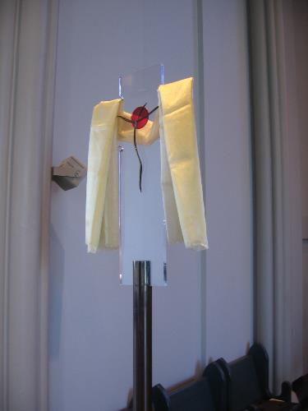
David Schmitt. Photograph from Concordia Seminary Chapel. April 25, 2014.

Public domain

Processional Cross, Concordia Seminary

Sermon 2: The Resurrecting Christ
Proper 8 (Romans 7:1-13)

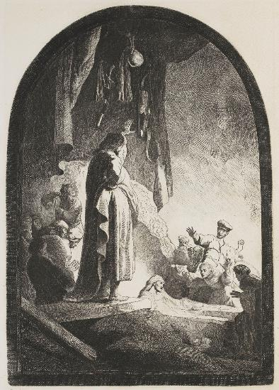
http://commons.wikimedia.org/wiki/File:B073_Rembrandt.jpg

Attribution: Rembrandt [Public domain], via Wikimedia Commons

Rembrandt, The Raising of Lazarus, c. 1630

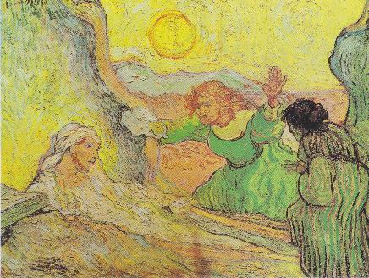
http://commons.wikimedia.org/wiki/File%3AVan_Gogh_-_Die_Auferweckung_des_Lazerus_(nach_Rembrandt).jpeg

Attribution: Vincent van Gogh, Public domain, via Wikimedia Commons

Van Gogh, The Raising of Lazarus (after Rembrandt), 1890

Sermon 3: Christ, Our Deliverer
Proper 9 (Romans 7:14-25a)

For images of the Boscoreale cup, with Augustus surrounded by gods and ruling over people, see plates 2 BRI:1 (Augustan’s world rule) and 5 BRI:2 (Augustus, Drusus) at http://publishing.cdlib.org/ucpressebooks/view?docId=ft309nb1mw&chunk.id=d0e367&toc.id=d0e182&brand=ucpress

For an image of Augustus, with power and mercy, that is in the public domain, see the following:
http://commons.wikimedia.org/wiki/File%3ARome_Statue_of_Augustus.jpg

Attribution: By Alexander Z. (Own work) [GFDL (http://www.gnu.org/copyleft/fdl.html) or CC-BY-SA-3.0 (http://creativecommons.org/licenses/by-sa/3.0/)], via Wikimedia Commons
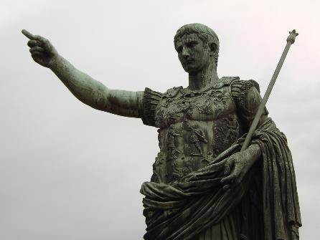

Statue of Augustus on the Via dei Fiori Imperiali, Rome

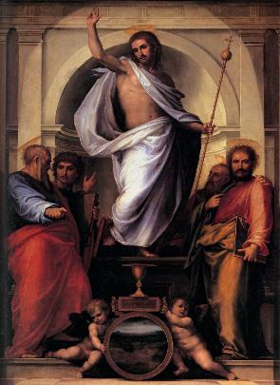
http://commons.wikimedia.org/wiki/File:Fra_bartolomeo_03_Christ_with_the_Four_Evangelists.jpg

Attribution: Fra Bartolomeo Public domain, via Wikimedia Commons

Fra Bartolommeo, Christ and the Four Evangelists, c. 1516

Sermon 4: God, Our Father
Proper 10 (Romans 8:12-17)

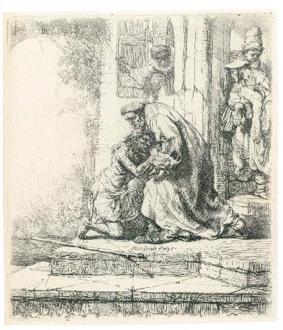
http://commons.wikimedia.org/wiki/File:Rembrandt_-_The_Return_of_the_Prodigal_Son.jpg

Attribution: Rembrandt, Public domain, via Wikimedia Commons

Rembrandt, The Return of the Prodigal Son, c. 1636

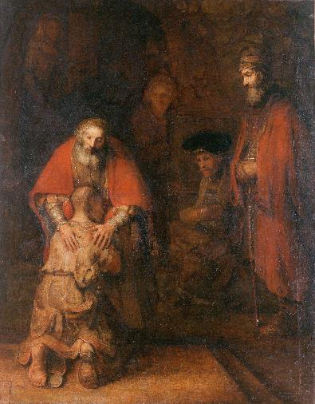
http://commons.wikimedia.org/wiki/File:Rembrandt_Harmensz._van_Rijn_-_The_Return_of_the_Prodigal_Son.jpg

Attribution: Rembrandt, Public domain, via Wikimedia Commons

Rembrandt, The Return of the Prodigal Son, c. 1668

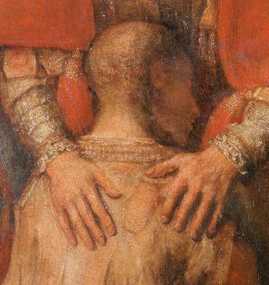
http://commons.wikimedia.org/wiki/File:Rembrandt_Harmensz._van_Rijn_-_The_Return_of_the_Prodigal_Son_-_detail_son.jpg

Attribution: By Rembrandt Harmenszoon van Rijn derivative work: carulmare, Public domain, via Wikimedia Commons

Rembrandt, The Return of the Prodigal Son, c. 1668 (detail)

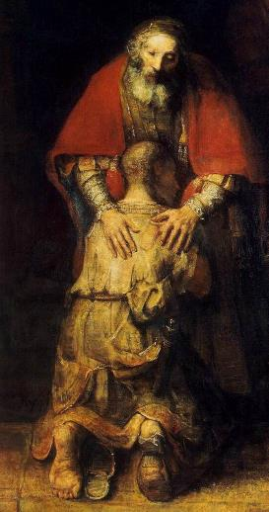
http://commons.wikimedia.org/wiki/File:Rembrandt_-_The_Return_of_the_Prodigal_Son_(detail)_-_WGA19137.jpg

Attribution: Rembrandt, Public domain, via Wikimedia Commons

Rembrandt, The Return of the Prodigal Son, c. 1668 (detail)

Sermon 5: Holy Spirit, Our Intercessor
Proper 11 (Romans 8:18-27)

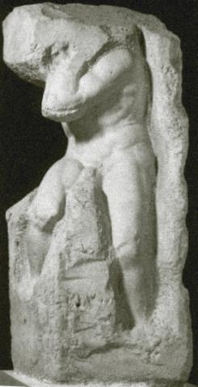
http://commons.wikimedia.org/wiki/File%3AMichelangelo_-_Atlas.jpg

Attribution: Michelangelo, by Anonymous (Гнедич. "История искусств"), Public domain, via Wikimedia Commons

Michelangelo, Atlas, c. 1530-1536

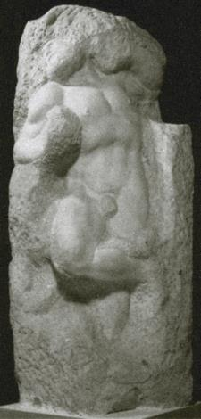
http://commons.wikimedia.org/wiki/File%3AMichelangelo_-_Awakening_slave.jpg

Attribution: Michelangelo, by Anonymous (Гнедич. "История искусств"), Public domain, via Wikimedia Commons

Michelangelo, Awakening Slave, c. 1530-1536

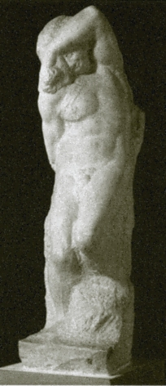
http://commons.wikimedia.org/wiki/File%3AMichelangelo_-_Young_slave.jpg

Attribution: Michelangelo, by Anonymous (Гнедич. "История искусств"), Public domain, via Wikimedia Commons

Michelangelo, Young Slave, c. 1530-1536

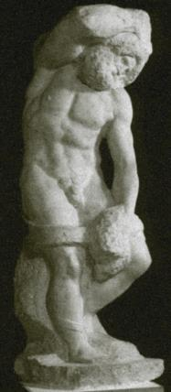
http://commons.wikimedia.org/wiki/File%3AMichelangelo_-_Bearded_slave.jpg

Attribution: Michelangelo, by Anonymous (Гнедич. "История искусств"), Public domain, via Wikimedia Commons

Michelangelo, Bearded Slave, c. 1530-1536

Sermon 6: God, in Love, Ruling over Ruins
Proper 12 (Romans 8:28-39)

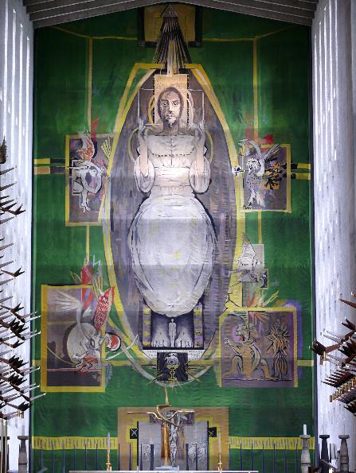
http://commons.wikimedia.org/wiki/File%3AGraham_Sutherland_Tapestry_-Coventry_Cathedral.jpg

Attribution: By David Jones [CC-BY-2.0 (http://creativecommons.org/licenses/by/2.0)], via Wikimedia Commons

Graham Sutherland, Christ in Glory in the Tetramorph, 1962.

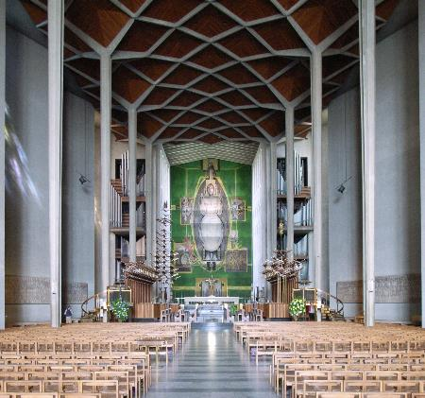
http://commons.wikimedia.org/wiki/File%3AGraham_Sutherland_Tapestry_-Coventry_Cathedral_-5July2008.jpg

Attribution: By Steve Cadman (originally posted to Flickr as Coventry Cathedral) [CC-BY-SA-2.0 (http://creativecommons.org/licenses/by-sa/2.0)], via Wikimedia Commons

Graham Sutherland, Christ in Glory in the Tetramorph, 1962.

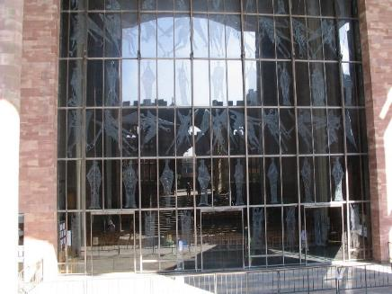
http://commons.wikimedia.org/wiki/File%3AWest_window%2C_Coventry_Cathedral_-_geograph.org.uk_-_555854.jpg

Attribution: E Gammie [CC-BY-SA-2.0 (http://creativecommons.org/licenses/by-sa/2.0)], via Wikimedia Commons

John Hutton, Screen of Saints and Angels, c. 1963

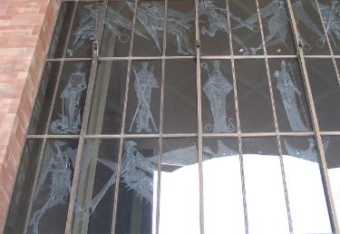
http://commons.wikimedia.org/wiki/File%3APatron_saints_and_flying_angels_-_geograph.org.uk_-_1267754.jpg

Attribution: E Gammie [CC-BY-SA-2.0 (http://creativecommons.org/licenses/by-sa/2.0)], via Wikimedia Commons

John Hutton, Screen of Saints and Angels, c. 1963 (detail)

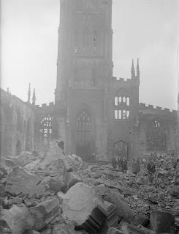
http://commons.wikimedia.org/wiki/File%3AOperation_Moonlight_Sonata-_Bomb_Damage_in_Coventry%2C_November_1940_H5604.jpg

Attribution: By War Office official photographer, Taylor, E A (Lieutenant), Public domain, via Wikimedia Commons

Bomb Damage in Coventry

http://commons.wikimedia.org/wiki/File%3ACoventry_Cathedral_Ruins_550.jpg

Attribution: By G-Man at en.wikipedia [GFDL (www.gnu.org/copyleft/fdl.html) or CC-BY-SA-3.0 (http://creativecommons.org/licenses/by-sa/3.0/)], from Wikimedia Commons

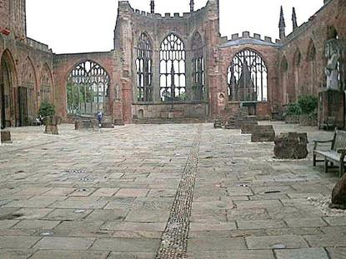

Coventry Cathedral Ruins

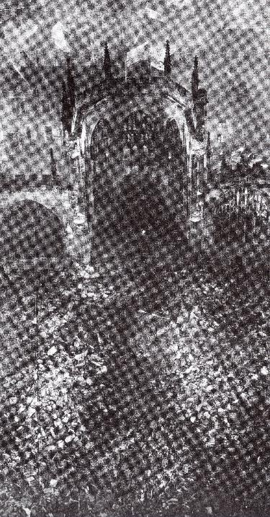
http://commons.wikimedia.org/wiki/File%3ACoventry_Cathedral_after_the_air_raid_in_1940.jpg

Attribution: By GoShow (Own work) [CC-BY-SA-3.0 (http://creativecommons.org/licenses/by-sa/3.0)], via Wikimedia Commons

Coventry Cathedral Ruins

http://commons.wikimedia.org/wiki/File%3ACoventry%2C_Spring_1944-_Everyday_Life_in_Coventry%2C_Warwickshire%2C_England%2C_UK%2C_1944_D18095.jpg

Attribution: By Joysmith Eric, Ministry of Information Photo Division Photographer, Public domain, via Wikimedia Commons

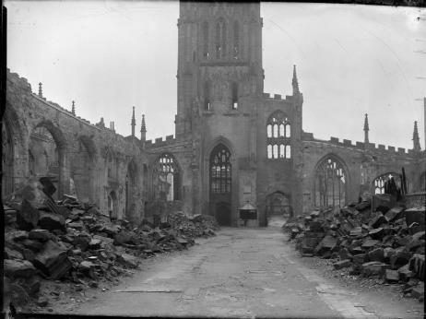

Coventry Cathedral Ruins

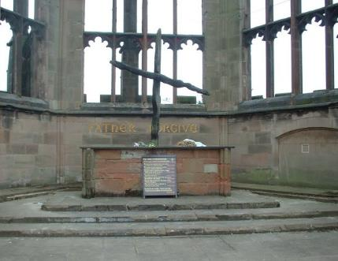
http://commons.wikimedia.org/wiki/File:Coventry_Cathedral_burnt_cross.jpg

Attribution: Photo by sannse, 28th August 2003, licensed under the Creative Commons Attribution-Share Alike 3.0 Unported license

Charred Cross, Coventry Cathedral

Sermon 7: People of the Promise
Proper 13 (Romans 9:1-5 (6-13))

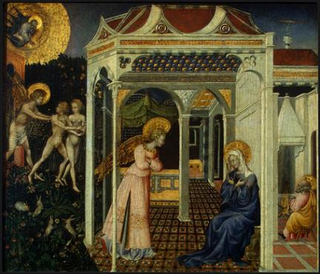
http://commons.wikimedia.org/wiki/File%3AGiovanni_di_Paolo_The_Annunciation_and_Expulsion_from_Paradise.jpg

Attribution: Giovanni di Paolo, Public domain, via Wikimedia Commons

Giovanni di Paolo di Grazia, The Annunciation and Expulsion from Paradise, 1445.

Sermon 8: People with a Purpose
Proper 14 (Romans 10:5-17)

For the image of Salvador Dali’s Christ of St. John of the Cross (1951), see http://en.wikipedia.org/wiki/Christ_of_Saint_John_of_the_Cross. Since the image is not in the public domain and cannot be reproduced on a bulletin insert, you may want to use an image of the museum in which it was vandalized or an image of the sketch by St. John of the Cross upon which it was based. These images are within the public domain.

http://commons.wikimedia.org/wiki/File%3AKelvingrove_Art_Gallery_and_Museum..JPG

Attribution: By Carola Ceballos (Own work) [CC-BY-SA-3.0 (http://creativecommons.org/licenses/by-sa/3.0)], via Wikimedia Commons

Kelvingrove Art Museum

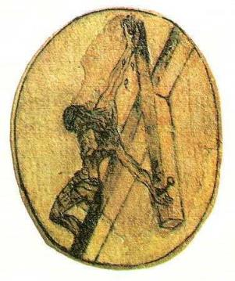
http://commons.wikimedia.org/wiki/File%3AJohn_of_the_Cross_crucifixion_sketch.jpg

Attribution: St. John of the Cross, Public domain, via Wikimedia Commons

Christ of St. John of the Cross

Sermon 9: People who Live by God’s Proclamation
Proper 15 (Romans 11:1-2a, 13-14, 28-32)

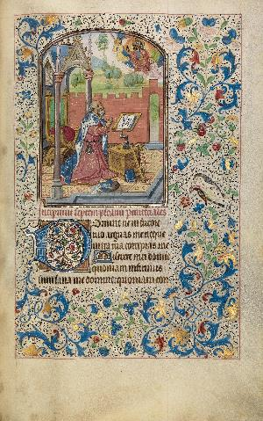
http://commons.wikimedia.org/wiki/File%3AWillem_Vrelant_(Flemish%2C_died_1481%2C_active_1454_-_1481)_-_David_in_Prayer_-_Google_Art_Project.jpg

Attribution: By Willem Vrelant (Flemish, died 1481, active 1454 - 1481) 1481
(Flemish) (illuminator, Details of artist on Google Art Project), Public domain, via Wikimedia Commons

Willem Vrelant, David in Prayer, c. 1454-1481

Sermon 10: Transformed for Service
Proper 16 (Romans 11:33 – 12:8)

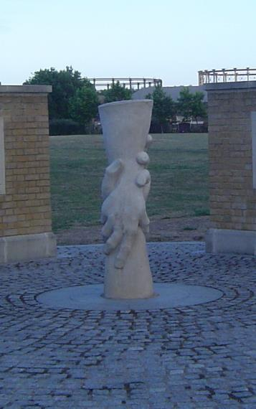
http://commons.wikimedia.org/wiki/File%3ASaving_hands.jpg

Attribution: By Gordon Joly (Own work) [CC-BY-SA-1.0 (http://creativecommons.org/licenses/by-sa/1.0)], via Wikimedia Commons

Monument at Three Mills Green, East London, UK, Workers’ Memorial, 2001

Sermon 11: Living in Love
Proper 17 (Romans 12:9-21)

http://commons.wikimedia.org/wiki/File%3AAraPacisFullFrontal2.JPG

Attribution: Photo by Chris Nas; sculpture by unknown Roman artist (Photo by Chris Nas) [GFDL (http://www.gnu.org/copyleft/fdl.html) or CC-BY-SA-3.0-2.5-2.0-1.0 (http://creativecommons.org/licenses/by-sa/3.0)], via Wikimedia Commons

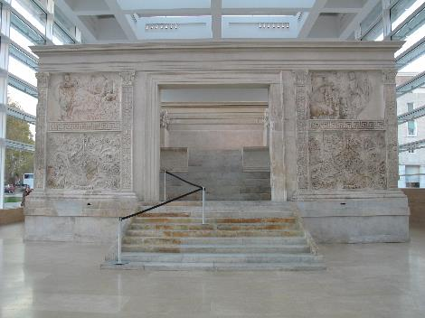

Ara Pacis, 9 BC (full view)

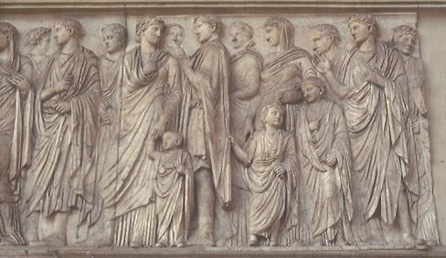
http://commons.wikimedia.org/wiki/File:RomaAraPacis_ProcessioneSudParticolare.jpg

Attribution: GFDL (http://www.gnu.org/copyleft/fdl.html) or CC-BY-SA-3.0-
2.5-2.0-1.0 (http://creativecommons.org/licenses/by-sa/3.0)], via Wikimedia Commons

Ara Pacis, 9 BC (south relief)

http://commons.wikimedia.org/wiki/File:RomaAraPacis_ProcessioneNordParticolare.jpg

Attribution: By MM from IT [GFDL (http://www.gnu.org/copyleft/fdl.html) or CC-BY-SA-3.0-2.5-2.0-1.0 (http://creativecommons.org/licenses/by-sa/3.0)], via Wikimedia Commons

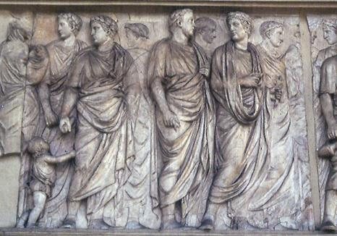

Ara Pacis, 9 BC (north relief)

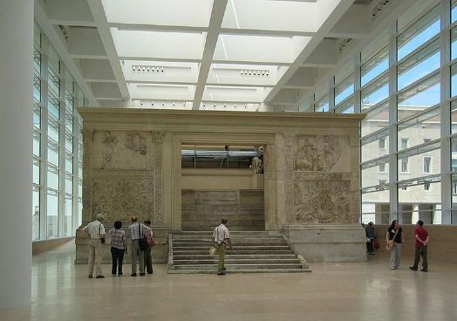
http://commons.wikimedia.org/wiki/File:Ara_Pacis-Ben_Demey.jpg

Attribution: By Ben Demey (Own work) [CC-BY-SA-2.0
(http://creativecommons.org/licenses/by-sa/2.0)], via Wikimedia Commons

Ara Pacis, 9 BC (museum view)

Sermon 12: Living in Mercy and Faithful Obedience
Proper 18 (Romans 13:1-10)

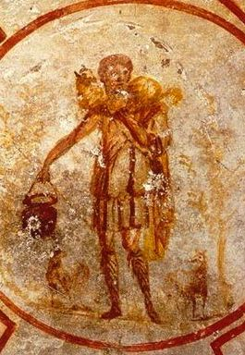
http://commons.wikimedia.org/wiki/File:Good_shepherd_02.jpg

Attribution: Jesus as the Good Shepherd. Ceiling – S. Callisto catacomb (mid 3rd century AD), Public domain, via wikimedia

Jesus as the Good Shepherd, mid 3rd century AD

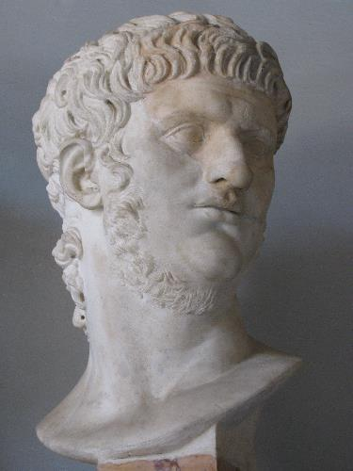
http://commons.wikimedia.org/wiki/File%3ANero_1.JPG

Attribution: By cjh1452000 (Own work) [CC-BY-SA-3.0 (http://creativecommons.org/licenses/by-sa/3.0) or GFDL (http://www.gnu.org/copyleft/fdl.html)], via Wikimedia Commons

Bust of Nero at the Capitoline Museum, Rome
Sermon 13: Living in Light of Christ’s Eternal Rule
Proper 19 (Romans 14:1-12)

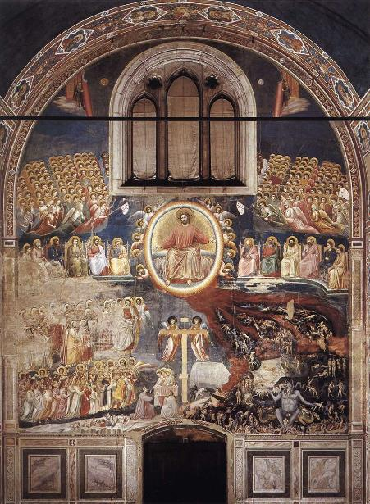
http://commons.wikimedia.org/wiki/File%3AGiotto_di_Bondone_-_Last_Judgment_-_WGA09228.jpg

Attribution: Giotto, Public domain, via Wikimedia Commons

Giotto di Bondone, Last Judgment, 1306

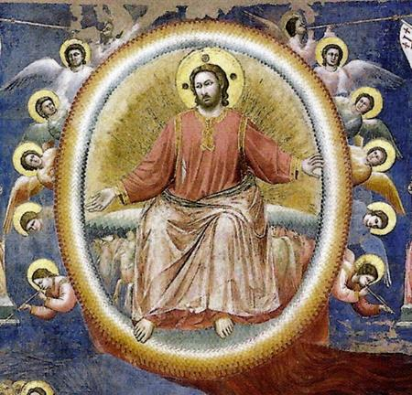
http://commons.wikimedia.org/wiki/File%3ALast-judgment-scrovegni-chapel-giotto-1306.jpg

Attribution: Giotto, Public domain, via Wikimedia Commons

Giotto di Bondone, Last Judgment, 1306 (detail)

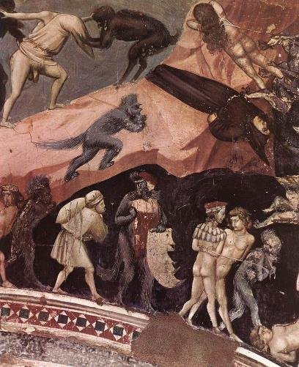
http://commons.wikimedia.org/wiki/File%3AGiotto_di_Bondone_-_Last_Judgment_(detail)_-_WGA09245.jpg

Attribution: Giotto, Public domain, via Wikimedia Commons

Giotto di Bondone, Last Judgment, 1306 (detail)

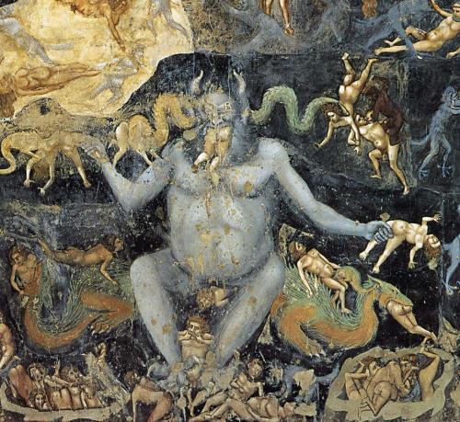
http://commons.wikimedia.org/wiki/File%3AGiotto_di_Bondone_-_Last_Judgment_(detail)_-_WGA09243.jpg

Attribution: Giotto, Public domain, via Wikimedia Commons

Giotto di Bondone, Last Judgment, 1306 (detail)

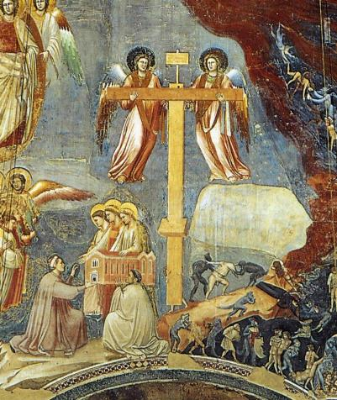
http://commons.wikimedia.org/wiki/File%3AGiotto_di_Bondone_-_Last_Judgment_(detail)_-_WGA09238.jpg

Attribution: Giotto, Public domain, via Wikimedia Commons

Giotto di Bondone, Last Judgment, 1306 (detail)

All images provided with this sermon series are in public domain and therefore can be printed on bulletin covers or inserts for use during the sermon. For more information on the image-based frame and reframe sermon structure, see http://concordiatheology.org/sermon-structs/dynamic/imagistic-structures/frame-refrain/
For more information on the image-based frame and refrain sermon structure, see http://concordiatheology.org/sermon-structs/dynamic/imagistic-structures/frame-refrain/
For more information on the multiple image sermon structure, see http://concordiatheology.org/sermon-structs/dynamic/imagistic-structures/multiple-image/
Salvadore Billi, a Florentine merchant, asked Fra Bartolommeo to paint this piece and then placed it in the chapel of SS. Annunziata de’ Servi. It was later purchased by Medici (1618) for his private chapel.
If you are displaying images during the sermon, I would encourage you at this point to incorporate images from the congregation that would highlight communion in that time and place.
For more information on the central image sermon structure, see http://concordiatheology.org/sermon-structs/dynamic/imagistic-structures/central-image/
Henri Nouwen, The Return of the Prodigal Son (New York: Doubleday, 1992), 54.
For more information on the central image sermon structure, see http://concordiatheology.org/sermon-structs/dynamic/imagistic-structures/central-image/
For more information on the multiple image sermon structure, see http://concordiatheology.org/sermon-structs/dynamic/imagistic-structures/multiple-image/
For more information on the image-delayed sermon structure, see http://concordiatheology.org/sermon-structs/dynamic/imagistic-structures/image-delayed/
Timothy E. Saleska, “Third Sunday in Lent, Year C” in The Lectionary Commentary: Theological Exegesis for Sunday’s Texts. The First Readings, ed. Roger E. Van Harn (Grand Rapids: Eerdmans, 2001), 365-366.
For more information on the central image sermon structure, see http://concordiatheology.org/sermon-structs/dynamic/imagistic-structures/central-image/
For more information on the central image sermon structure, see http://concordiatheology.org/sermon-structs/dynamic/imagistic-structures/central-image/
For more information on the image-delayed sermon structure, see http://concordiatheology.org/sermon-structs/dynamic/imagistic-structures/image-delayed/
Elizabeth Barrett Browning. “Aurora Leigh” in The Poetical Works of Elizabeth Barrett Browning (London: University Press, 1920), 499.
For more information on the central image sermon structure, see http://concordiatheology.org/sermon-structs/dynamic/imagistic-structures/central-image/
For more information on the multiple image sermon structure, see http://concordiatheology.org/sermon-structs/dynamic/imagistic-structures/multiple-image/
Jean de la Fontaine, “The Arbiter, the Hospitaler, and the Hermit” in The Complete Fables of La Fontaine, trans. Norman R. Shapiro (Chicago: University of Illinois Press, 2007) : 397.
Edwin Guest, Origines Celticae Vol. 2 (London: Macmillan and Co., 1883): 102.
Miriam Tamara Griffin, Nero: The End of a Dynasty (London: Routledge, 1984), 96.
Lucius Annasus Seneca, “On Mercy” in Moral Essays Vol. 1 (London: W. Heinemann, 1928), 357-359.
Neil Elliot, The Arrogance of Nations: Reading Romans in the Shadow of Empire (Minneapolis: Fortress Press, 2008), 155-156.
For more information on the central image sermon structure, see http://concordiatheology.org/sermon-structs/dynamic/imagistic-structures/central-image/

